 | CAPSTONE PROJECT  Final Report

CREDIT RISK AND LOAN DEFAULT PREDICTION:
USING MACHINE LEARNING, STATISTICAL MODELLING
AND EXPLAINABLE AI TECHNIQUES
Prepared by:
Aphelele Siphelele Gwebityala
202430482
Department of Computer Science and Information Technology
Sol Plaatje University
Submitted to:
Mrs Nthabiseng Modiba
Lecturer: Capstone Project – NCSP730
Department of Computer Science and Information Technology
Sol Plaatje University
24 to 26 Scanlan Street, New Park, Kimberley, 8301
October 2026

EXECUTIVE SUMMARY
Loan default costs banks and their customers dearly and South Africa has felt this keenly in recent years. Absa, FirstRand, Nedbank and Standard Bank together recorded R27.1 billion in bad debt charges in the first half of 2024 alone (PwC, 2025). I began this project with a question that is as personal as it is professional, as I move from studying Data Science into the adult world of car loans and home loans, do the institutions that will lend to me actually have reliable, fair tools for deciding who can repay and at what interest rate? Credit Risk and Loan Default Prediction answers that question by building a system that estimates the probability a loan applicant will default using only the information a lender has at the point of application, while keeping every prediction explainable enough for a credit officer, a regulator or the applicant themselves to follow.
I worked with the Loan Default dataset published on Kaggle, 255 347 records across 18 variables and I followed the CRISP DM methodology from business understanding through to a working Streamlit dashboard. My proposal set out three primary models namely logistic regression with Lasso regularization, probit regression and a Random Forest benchmark, with class imbalance handled through SMOTE and SHAP explanations built on the Random Forest. Over the course of implementation I added XGBoost once it proved to be the stronger benchmark and I made one significant correction to my original plan, SMOTE, the
oversampling technique my proposal specified, turned out to distort the model's calibration so badly that a Hosmer Lemeshow test rejected it outright. I replaced SMOTE with class weighting across every classifier, which is the change I consider the single most important methodological decision in this report and I explain exactly why in Chapter 5.
The final XGBoost model, trained with class weighting and then calibrated, reached a cross validated AUC of 0.7528 and a test AUC of 0.7587, matching Logistic Regression (0.7532) and Random Forest (0.7525) almost exactly once every model received the same fair treatment of the imbalance. That near tie is itself a finding. In an earlier, less careful comparison, XGBoost looked like the clear winner and that gap turned out to be an artefact of SMOTE rather than a genuine difference between the algorithms. Isotonic calibration corrected a severe probability problem in the raw XGBoost output (the Hosmer Lemeshow test moved from p below 0.0001 to p equal to 0.0999) and SHAP analysis named applicant age, interest rate, months employed and income as the strongest drivers of predicted risk. An Information Value analysis, run independently of SHAP, landed on the same short list and surfaced a result that genuinely surprised me. The applicant's existing credit score carries almost no independent predictive power in this dataset, classed as useless by the standard Information Value rule of thumb once age, interest rate and income are already
known.
This report documents the whole journey of the project, from the original proposal through an intermediate version that still relied on SMOTE, to the corrected analysis presented here and it explains every input feature in plain language so that a reader with no statistics background can follow what the model is doing and why. I have tried to write it the way I would want a report written for me, honest about what changed and why, clear about what the numbers mean and useful to anyone, technical or not, who needs to trust a lending decision.
BUSINESS DOMAIN
This project sits in the financial services sector and specifically in consumer credit risk assessment. The intended client is the South African banking and lending industry, meaning the risk analytics and credit assessment departments inside commercial banks such as Absa, FirstRand, Nedbank and Standard Bank, together with the smaller registered credit providers that operate under the National Credit Act. The National Credit Regulator and financial technology companies running digital lending platforms are also a natural audience for this work, since both groups are directly affected by how accurately and how fairly a lending decision is made.
Within those institutions, the primary users are credit risk officers, the data science teams that build and maintain scoring systems and the senior decision makers who must sign off on a bank's lending policy. What this project hands to that user group is a probability of default for each applicant, a three-tier risk classification built on that probability and a SHAP based explanation of the factors driving the score, all wrapped into an interactive dashboard a credit officer can use without writing a line of code. The intention throughout has been that this output could slot directly into a credit approval workflow, improving the accuracy, consistency, fairness and regulatory defensibility of lending decisions, rather than sitting as an academic exercise separate from how a bank actually works.
Lenders who extend credit under the National Credit Act carry a specific obligation that shapes this entire report, they must be able to explain an individual credit decision to the person it affects. Basel III places a parallel obligation on banks to use statistically validated models for estimating the probability of default on every loan in their books (Basel Committee on Banking Supervision, 2017). A system built for this domain therefore must satisfy two audiences at once, a technical one that wants accuracy and a regulatory one that wants an explanation and that dual requirement is what drives nearly every modelling choice described in the chapters that follow.
1. INTRODUCTION
A loan default happens when a borrower stops repaying what they owe and for a bank that single event can unravel years of careful lending. South Africa's four largest banks, namely Absa, FirstRand, Nedbank and Standard Bank, booked a combined R27.1 billion in bad debt charges in just the first half of 2024 (PwC, 2025). Every one of those billions began as a decision made at a loan application, a moment when a bank had to judge, often in minutes, whether a stranger would repay what they were asking to borrow. Getting that judgement wrong in either direction carries a cost, approve too freely and defaults pile up, decline too cautiously and the bank turns away customers who would have repaid reliably. This project builds a model that supports that judgement with evidence rather than instinct, estimating the probability that a given applicant will default before the loan is ever approved.
Banks have used statistical scoring for decades and in recent years many have moved toward machine learning models that promise sharper predictions than a traditional logistic regression scorecard. That promise comes with a cost of its own. A complex ensemble model such as Random Forest or XGBoost can be meaningfully more accurate than a simple scorecard, yet it is also far harder for a human being to interrogate. Under the National Credit Act, a South African lender who declines an applicant must be able to explain why and Basel III requires banks to use statistically validated models for estimating default risk (Basel Committee on Banking Supervision, 2017). A model nobody can explain is not a model a regulated bank can actually deploy, however accurate it looks on a test set. The tension between accuracy and explainability sits at the centre of this entire report and the choice made throughout is not to pick one side of that tension but to refuse the tradeoff. Every model built here is paired with an explanation method capable of showing exactly why it produced the score it did.
I used the Loan Default dataset published on Kaggle, 255 347 loan records described by 18 variables covering applicant demographics, loan terms and credit history, with a binary target indicating whether the loan went on to default. I followed the Cross Industry Standard Process for Data Mining, usually shortened to CRISP DM, as the backbone of the whole project, moving from business understanding through data understanding, data preparation, modelling and evaluation, to a deployed Streamlit dashboard. Four models anchor the comparison at the centre of this work, Logistic Regression with Lasso regularisation as the interpretable baseline, a Random Forest and an XGBoost classifier as stronger but less transparent benchmarks and a Weight of Evidence credit scorecard built for maximum interpretability. All four are explained using SHAP, an Information Value analysis or both.
This report also documents a correction I made partway through the project, because I think the reasoning behind it matters as much as the final numbers. My original plan, set out in the proposal that forms part of this report, called for SMOTE to correct the class imbalance in the data, following common practice in the credit scoring literature. Once I tested the resulting model properly, using a Hosmer Lemeshow test rather than accuracy alone, I found that SMOTE had badly distorted the model's predicted probabilities. I replaced SMOTE with class weighting, a simpler technique that adjusts how much each class counts during training rather than fabricating synthetic examples, and the calibration problem disappeared. Chapter 5 of this report explains that change in full, because an honest account of what did not work the first time is, in my view, worth more than a report that only shows the version that succeeded.
The remainder of this report is organised to follow that journey from problem to solution. The Problem and Objectives chapter states exactly what this project set out to achieve and the measurable targets it was judged against. The Literature Review places the project in the context of existing research on credit scoring, class imbalance and explainable artificial intelligence. The Scope chapter draws a clear boundary around what this project does and does not attempt. The Solution chapter walks through the full methodology, including the SMOTE correction. Final Model Results presents the numbers produced by every model, the SHAP and Information Value explanations and the scorecard built from them. Recommendations closes the report by translating those results into practical guidance for a bank considering a system like this one, together with an honest look at its limitations and the risks of deploying it without care.

2. PROBLEM AND OBJECTIVES
2.1 Problem Statement
Lenders need to estimate, before a loan is disbursed, how likely an applicant is to default and they need that estimate to satisfy two requirements that are often treated as if they pull in opposite directions. The estimate has to be accurate enough to be useful, meaning it should separate likely defaulters from likely repayers better than a coin flip or a handful of simple rules. It also has to be explainable enough to meet the regulatory and ethical demands placed on consumer lending in South Africa, where a declined applicant is entitled to understand why. A purely statistical model such as logistic regression is easy to explain but can leave predictive power on the table. A complex ensemble model can capture more of the pattern in the data but resists explanation unless it is paired with a dedicated interpretability technique. This project treats that as the central problem to solve, build and compare models across that spectrum, from fully transparent to deliberately complex and prove that each one can be made explainable without giving up meaningful accuracy.
A second, more technical problem sits underneath the first. Loan default is a rare event relative to loan repayment and the dataset used in this project reflects that: only 11.61% of the 255 347 records are defaults. A model trained carelessly on imbalanced data can achieve a deceptively high accuracy simply by predicting that nobody will default, which is exactly the trap that Zhou and Wang (2012) and Zurada (2002) document in their own credit scoring studies. Correcting for that imbalance without breaking the model's probability outputs, meaning without making its predicted probabilities systematically wrong even when its ranking of risky applicants is sound, turned out to be a genuine technical problem and solving it is one of this report's main contributions.
2.2 Business Objectives
Four business objectives, each stated in SMART terms in the original proposal, guided this project from start to finish.
- Predictive Modelling: Build a primary model, Logistic Regression with Lasso regularisation, that reaches an AUC ROC of at least 0.75, a recall of at least 0.65 and a precision of at least 0.60 on a held-out test set by the end of the project.
- Model Comparison and Benchmarking: Compare that primary model against Random Forest and a probit specification using AUC ROC, F1 score, recall, precision, AIC, BIC, McFadden pseudo R squared and the Hosmer Lemeshow goodness of fit test, so that the choice of final model rests on evidence rather than on a single metric.
- Explainability: Apply SHAP to the strongest benchmark model so that every prediction can be broken down into the contribution of each individual feature, for the top ten predictors at minimum, with both a global summary plot and individual waterfall explanations.
- Actionable Deployment: Translate the model's output into a practical risk scoring framework, complete with recommendations a lender could act on, rather than leaving the analysis as a purely academic exercise.
The proposal also set three concrete success criteria against which the finished project would be judged, an AUC ROC of at least 0.75 and a recall of at least 0.65 on the held-out test set, a Hosmer Lemeshow test that fails to reject the null hypothesis of good calibration at the 5% significance level and a SHAP analysis covering the ten most important predictors with at least three individual waterfall explanations. As Chapter 6 shows in full, this project met every one of those criteria, including the calibration target, which only became achievable after the SMOTE correction described in Chapter 5.
Over the course of implementation, the scope grew slightly beyond these four original objectives. XGBoost was added once early testing showed it to be a stronger benchmark than the Random Forest alone and a Weight of Evidence credit scorecard was built as a fifth, maximally interpretable model, using the optbinning library. Both additions are consistent with the spirit of the original objectives, accuracy compared fairly across models and explainability treated as a requirement rather than an afterthought and neither one replaces or weakens the commitments made in the proposal.

3. LITERATURE REVIEW
Credit risk modelling is one of the oldest applied problems in statistics and it has also become one of the clearest test cases for how machine learning and explainable artificial intelligence meet the demands of a regulated industry. This chapter reviews the research that shaped the decisions made throughout this project, moving from the history of credit scoring, through the classical and machine learning models compared here, to the specific problem of class imbalance that forced a change in the project's own methodology and finally to the explainability techniques used to interpret the results. Each theme ends by stating what the cited work means for a specific decision made in this report, so that the link between the literature and the actual pipeline is never left implicit.
3.1 The History of Credit Risk Modelling
Lenders have been scoring borrowers systematically since the middle of the twentieth century, but the field only became a precise, regulated discipline once international banking standards required it. The Basel Committee on Banking Supervision (2017) set out the modern expectation directly where banks must use statistically validated models to estimate the probability of default, the loss given default and the exposure at default for every loan on their books. That single requirement is the reason credit scoring cannot be treated as a purely technical exercise. A model built for this domain has to satisfy an external auditor as much as it has to satisfy a data scientist, and it has to do so for every individual decision, not only on average across a portfolio. This project treats that regulatory context as a design constraint from the outset rather than an afterthought, which is why explainability is tested and reported for every model built here, not only the one eventually recommended for deployment.
3.2 Classical Statistical Models for Binary Outcomes
Logistic regression remains the default starting point for predicting a binary outcome such as default or repayment and Hosmer and Lemeshow (2013) give the method its most complete statistical treatment, including the goodness of fit test that carries their name. That test compares a model's predicted probabilities against the default rates observed in groups of similar applicants and it is far stricter than simply checking whether a model ranks risky applicants above safe ones. A model can separate the two groups well while still producing probabilities that are systematically too high or too low, and only a calibration test such as Hosmer Lemeshow's will catch that. This project leans on that distinction heavily in Chapter 5, because it was exactly this test and not accuracy or AUC, that first revealed a serious problem with the original modelling approach.
Agresti (2013) extends the same family of models to the probit specification used alongside logistic regression in this project and explains why the two usually produce similar predictions despite resting on different assumed distributions for the underlying error term. Tibshirani (1996) introduced Lasso regularisation, the technique specified in this project's proposal for the primary logistic regression model, which shrinks the coefficients of weak predictors toward zero and can remove them from the model entirely. That property matters for a credit scorecard because a simpler model with fewer active predictors is both easier to audit and less likely to have overfitted to noise in the training data, a consideration that shaped the choice to use Lasso rather than an unregularised logistic regression as the primary interpretable model in this project.
3.3 Machine Learning Approaches
Where classical statistical models assume a specific mathematical form for the relationship between predictors and outcome, ensemble machine learning methods learn that relationship directly from the data, usually at some cost to interpretability. Breiman (2001) introduced the Random Forest algorithm, which trains many decision trees on different random subsets of the data and averages their predictions, a strategy that reduces the variance any single tree would carry and generally improves how well the model generalises to new applicants. Chen and Guestrin (2016) introduced XGBoost, a gradient boosted tree method that builds trees sequentially, with each new tree correcting the errors of the ones before it, and reported state of the art results on structured, tabular data of exactly the kind used in this project. Noriega, Rivera and Herrera (2023) reviewed the published credit risk literature between 2015 and 2023 and found that ensemble methods such as these two consistently beat logistic regression on raw accuracy, though they also note that few of the studies they reviewed tested whether those more accurate models were properly calibrated. That gap is precisely what this project set out to close, by subjecting every model, not only the ensembles, to the same calibration test described above.
James, Witten, Hastie and Tibshirani (2021) provide the broader statistical learning framework this project draws on when comparing models of different complexity, particularly their treatment of the bias variance trade off, which explains why a more flexible model such as XGBoost can fit the training data more closely without necessarily predicting better on new applicants. Martin, Taheri and Abdollahian (2024) applied cost sensitive ensemble tuning directly to credit scorecard data and found that ensembles reduce the total cost of misclassification compared with logistic regression, but at a real cost to interpretability. Their finding is the direct justification for this project's decision to keep logistic regression as the primary, most interpretable model while treating Random Forest and XGBoost as benchmarks rather than automatic replacements.
3.4 The Challenge of Class Imbalance and SMOTE
Default is rare compared with repayment in almost every consumer lending dataset and that imbalance can quietly sabotage a model that is not built to account for it. Zhou and Wang (2012), reviewed through Berdiyorov and Berdiyorov (2026), trained a Random Forest on more than 150 000 loan records and reported 93.6% overall accuracy alongside a balanced accuracy of only 57.6%, a gap that exposes how misleading plain accuracy becomes once one class dominates the data. Zurada (2002), reviewed in the same source, found a similar pattern on consumer loan data with an 8.9% default rate: 93.5% accuracy alongside only 42.4% of true defaulters correctly identified. Both results motivated the decision made early in this project to treat AUC, recall and F1 as the primary evaluation metrics, with accuracy reported only as a secondary figure, since accuracy alone would have hidden exactly the kind of weakness these two studies describe.
Chawla, Bowyer, Hall and Kegelmeyer (2002) introduced SMOTE, the Synthetic Minority Oversampling Technique, to correct class imbalance by generating synthetic examples of the minority class rather than simply duplicating existing ones. SMOTE is widely used in the credit scoring literature and was the technique specified in this project's original proposal. He and Garcia (2009) reviewed the broader landscape of imbalance correction methods and reached a more cautious conclusion than SMOTE's early popularity might suggest: no single correction method dominates across every dataset and the right choice depends on both the data and the goal of the model. That caution turned out to be well placed. As Chapter 5 documents in detail, SMOTE produced a severe calibration failure when applied to the dataset used in this project, and the final pipeline replaced it with class weighting, a conclusion reached only by testing both approaches directly rather than assuming the literature's most popular method would automatically be the right one for this data.
3.5 Stochastic Modelling of Borrower Behaviour
Beyond the purely statistical question of which model fits best, a smaller body of research asks why interest rate in particular is such a strong predictor of default. Stiglitz and Weiss (1981) offered the foundational answer in their theory of credit rationing under imperfect information, showing that raising the interest rate on a loan can perversely worsen the risk profile of the remaining applicant pool, because safer borrowers are the first to withdraw when rates rise, leaving a riskier group willing to accept the higher cost. Boiquaye, Aidoo and Gyamerah (2026) formalised a related mechanism using an Ornstein Uhlenbeck stochastic process and Monte Carlo simulation, showing that higher interest rates and greater volatility in a borrower's returns increase risk shifting behaviour and with it, the probability of default. Together these two sources give a theoretical account of exactly the pattern this project's own results surface independently, interest rate emerges as the strongest single risk increasing predictor in both the odds ratio analysis and the SHAP explanations presented in Chapter 6 and these studies explain why that relationship exists rather than simply observing that it does.
3.6 The South African Credit Market Context
The scale of the problem this project addresses is not abstract. PwC (2025) reported that South Africa's four largest banks, Absa, FirstRand, Nedbank and Standard Bank, recorded a combined R27.1 billion in bad debt charges in the first half of 2024 alone, a figure that puts a concrete financial weight behind every percentage point of recall or precision discussed later in this report. The Basel III framework described earlier applies directly to these institutions and the National Credit Act layers a further, South Africa specific obligation on top of it, requiring that a lender be able to explain an adverse credit decision to the applicant it affects. Sikho Bulela Mda's (2025) unpublished report is the closest comparable prior study available and is used throughout this report as a direct benchmark. Mda trained a Decision Tree, a Random Forest, an XGBoost classifier and a Multilayer Perceptron on a smaller Kaggle dataset of 32 581 records and 12 features, reaching a best test accuracy of 93.7% and an AUC of 0.866 with XGBoost, against a target of at least 90% accuracy stated in that report's own objectives. Mda addressed class imbalance through oversampling and class weight adjustment and explicitly named SMOTE as unexplored future work, a detail this project is able to follow up on directly, since SMOTE was tested here and found to cause the calibration problem described in Chapter 5. Chapter 6 of this report returns to this comparison with the full numbers side by side.
3.7 Explainable AI in Credit Risk
A model that cannot be explained is, in a regulated lending context, a model that cannot be used, however accurate it is. Lundberg and Lee (2017) addressed this directly by formalising SHAP, which stands for SHapley Additive exPlanations, grounding it in the concept of Shapley values from cooperative game theory. SHAP assigns each feature in a prediction a contribution value that satisfies two properties earlier, more ad hoc explanation methods lacked: consistency, meaning a feature's assigned importance cannot decrease if the model comes to depend on it more, and local accuracy, meaning the feature contributions always sum exactly to the difference between the model's prediction and its average output. Ribeiro, Singh and Guestrin (2016) had earlier proposed LIME, a faster but less theoretically grounded alternative that approximates a model locally with a simple linear model and can be locally unstable as a result. That comparison is the direct reason this project uses SHAP rather than LIME for every explanation presented in Chapter 6.
Misheva, Osterrieder, Hirsa, Kulkarni and Lin (2021) reviewed and applied several explainable AI methods, SHAP among them, directly to credit risk datasets and found that explainability can be added without materially reducing predictive accuracy, directly supporting this report's central argument that accuracy and explainability are not opposing goals. El Qadi, Diaz Rodriguez, Trocan and Frossard (2021) went a step further and compared SHAP's feature attributions against the reasoning of human expert credit analysts, finding that the two align closely, which lends real world credibility to SHAP beyond its mathematical properties alone. Chang, Xu, Akinloye, Benson and Hall (2024) ran a comparable study on real bank data, pairing tree ensembles with SHAP and finding that the resulting explanations matched expert judgement well. Each of these three studies supports the specific pairing used throughout this project: a tree-based ensemble, XGBoost, explained with SHAP's TreeExplainer, which is exact and efficient for tree models rather than relying on the slower general-purpose approximation SHAP requires for other model types.
3.8 Governance, Fairness and Model Risk in Credit Scoring
A final theme sits underneath every other one reviewed in this chapter: once a model is built, who is accountable for what it does. Barocas and Selbst (2016) examine how a model trained on historical data can reproduce the biases embedded in that history, disadvantaging groups the training data already disadvantaged, even when the model is never given a protected characteristic such as race or gender directly. Their argument is a direct caution against treating the absence of a protected field in a dataset, which is true of the Loan Default dataset used in this project, as proof that a model trained on it cannot discriminate. A feature such as employment type or geographic region can still correlate with a protected characteristic closely enough to reproduce the same disadvantage indirectly, a possibility this report returns to directly in Chapter 7.
Guidotti, Monreale, Ruggieri, Turini, Giannotti and Pedreschi (2018) survey the broader landscape of methods for explaining black box models, situating SHAP and LIME within a much larger family of techniques and making the point that no single explanation method is complete on its own, each one answers a slightly different question about why a model behaved the way it did. Molnar (2020) extends that survey into a practical guide aimed at practitioners rather than researchers, and the distinction Molnar draws between a model that is interpretable by design, such as the Weight of Evidence scorecard built in this project, and a model that is complex but explained after the fact, such as XGBoost paired with SHAP, maps directly onto the two deployment options this report ultimately offers in Chapter 6.
Moscato, Picariello and Sperli (2021) apply explainable artificial intelligence specifically to credit risk prediction and argue that explainability should be treated as a requirement engineered into a credit model from the start, not a feature added after a model has already been selected for its accuracy alone. That argument is close to the position this report has taken throughout: every model built here, from Logistic Regression through to XGBoost, was paired with an explanation method as part of its own evaluation, rather than explanation being bolted onto whichever model happened to score highest on accuracy. Burke and Dempsey (2022), writing specifically about how undergraduate capstone projects should be structured and reported, underline a related point this report has tried to honour throughout: a capstone's value lies as much in showing a defensible, transparent process as in the final numbers it produces, which is the reasoning behind documenting the SMOTE correction in Chapter 5 in full rather than presenting only the corrected pipeline as though it were the first approach tried.
Taken together, this body of research set three clear expectations for this project before any code was written: that ensemble models would likely outperform logistic regression on raw predictive power, that class imbalance would need deliberate correction and that correction could not simply be assumed to work without testing it properly, and that SHAP was the appropriate explainability method for whichever tree based model performed best. All three expectations were held, though the second one held in a more complicated way than the literature's emphasis on SMOTE might have suggested, which is the subject of the next chapter.

4. SCOPE
A project like this one could grow in almost any direction, from richer data sources to a full production deployment, so this chapter sets out exactly what was attempted and just as importantly, what was deliberately left out. Drawing a clear boundary here keeps the results in Chapter 6 honest about what they can and cannot claim.
4.1 In Scope
This project covers the full CRISP DM pipeline applied to a single, publicly available dataset. On the modelling side, four classifiers are trained, tuned and compared on the same train and test split: Logistic Regression with Lasso regularisation as the primary, interpretable model; a probit specification used for additional statistical comparison; a Random Forest; and an XGBoost classifier, which was added during implementation once early testing showed it to be the strongest benchmark available. A fifth, maximally interpretable model, a Weight of Evidence credit scorecard built with the optbinning library, is also constructed and evaluated alongside the four classifiers.
- Data preparation, including cleaning, encoding of categorical variables and an explicit, documented comparison between SMOTE oversampling and class weighting as two competing ways of handling class imbalance.
- Hyperparameter tuning and five-fold cross validation for every classifier, so that reported performance reflects a properly validated configuration rather than a single lucky split of the data.
- Probability calibration, tested with the Hosmer Lemeshow goodness of fit test and corrected with isotonic regression where needed.
- Explainability for every model, using SHAP for the tree-based classifiers and Weight of Evidence and Information Value analysis for the scorecard.
- Deployment of the final, calibrated model into an interactive Streamlit dashboard that a nontechnical user can operate directly.

4.2 Out of Scope
Several extensions were considered during planning and deliberately excluded, either because they fell outside the time available for an undergraduate capstone or because they would have changed the project's purpose from a comparative, explainable analysis into a production engineering exercise.
- Deep learning architectures, such as neural networks beyond the simple comparison already available through Mda's (2025) prior report, were not built here, since the proposal's own objectives centred on statistical and tree-based models rather than deep learning.
- External credit bureau data from providers such as TransUnion or Experian was not used. The dataset is limited to the applicant level information a lender would typically collect directly at the point of application.
- Real-time production deployment, including the infrastructure a bank would need to serve predictions on a scale with monitoring and retraining pipelines, is outside the scope of this project. The Streamlit dashboard built here is a demonstration of the model's output, not a production system.
- Portfolio level macroeconomic forecasting, such as projecting a bank's total expected losses under different economic scenarios, was not attempted. This project scores individual applicants rather than modelling the portfolio.
These boundaries mean the results that follow should be read as a rigorous comparative analysis and a working prototype, not as a finished banking product. Chapter 7, Recommendations, returns to this distinction when discussing what further work would be needed before a system like this one could move from a capstone project into an actual lending workflow.

4.3 Assumptions and Constraints
A handful of assumptions underpin every result in this report and stating them plainly here makes it easier to judge how far the findings can be generalised. The first assumption is that the Kaggle dataset used throughout is a reasonable proxy for a real South African lender's own applicant data. The dataset does not state its country of origin and its feature set, while realistic, is almost certainly simpler than the dozens of variables a real bank's risk team would have access to. Results built on it should therefore be read as a demonstration of method rather than a finished risk model ready for any specific institution.
A second assumption is that the relationship between an applicant's characteristics and their likelihood of default is reasonably stable over the period the data represents. Credit risk is known to shift with the broader economy, a loan that looks safe in a period of low interest rates can look very different once rates rise and this project does not attempt to model that kind of time dependence, since the dataset provides no application date to test it against.
The project was also constrained by the time available for an undergraduate capstone, which shaped several of the boundaries drawn in this chapter. Hyperparameter search grids were kept deliberately narrow once an initial coarse search identified promising ranges, rather than exhaustively searching every plausible configuration and the project worked from a single train and test split rather than repeating the full pipeline across multiple random splits, a trade off between thoroughness and the time available that a production grade study would not need to make.
4.4 Underlying Dataset Assumption
Because the two preceding assumptions shape every number in Chapter 6, it is worth stating directly what this project treats as given, that the sixteen features available in the dataset are the features a lender would reasonably have at the point of application and that the recorded default outcome is accurate and was not itself influenced by an earlier scoring model's decisions. Neither assumption can be verified from the data alone, since the dataset was not collected for this project and comes with no accompanying documentation describing exactly how it was gathered and both are common, reasonable starting points for an academic study of this kind.

5. SOLUTION
This chapter explains how the project was built, from the methodology that structured the work through to the specific implementation choices behind each model. It also contains the most important correction made during the project, the decision to abandon SMOTE, the oversampling technique specified in the original proposal, in favour of class weighting, after SMOTE was found to damage the calibration of every model it touched.
5.1 Overview of Methodology
The project follows the Cross Industry Standard Process for Data Mining, usually known by its acronym CRISP DM, which breaks a data science project into six phases namely business understanding, data understanding, data preparation, modelling, evaluation and deployment. CRISP DM was chosen because it keeps every modelling decision tied back to the business problem it is meant to solve, rather than letting technical sophistication become a goal in itself. Table 5.1 summarises what each phase involved in this project.
Table 5.1: CRISP DM phases as applied in this project.
Phase | What was done in this project
1. Business understanding | Define the problem, predicting loan default probability, and the dual objective of accuracy and explainability set out in Chapter 1.
2. Data understanding | Explore the Loan Default dataset: its shape, missing values, duplicate records, the distribution of the target variable, correlations between features, and default rates broken down by category.
3. Data preparation | Encode categorical variables, split the data into training and test sets using an 80/20 stratified split, scale numeric features for the linear models, and decide how to handle class imbalance.
4. Modelling | Train and tune Logistic Regression with L1 regularisation, a probit model, Random Forest, XGBoost, and a Weight of Evidence based scorecard.
5. Evaluation | Compare every model on AUC, precision, recall, F1 and accuracy, select an operating threshold using Youden's J statistic, calibrate predicted probabilities, and explain predictions using SHAP.
6. Deployment | Package the calibrated model and its supporting artefacts into an interactive Streamlit dashboard.
Table 5.2 lists the main software tools used across all six phases. The analysis was carried out entirely in Python, chosen for the maturity of its data science ecosystem and because it is the language this project's own undergraduate coursework is taught in.
Table 5.2: Software tools used in this project.
Tool or library | Role in this project
Python 3.12 | Primary programming language for the entire analysis.
pandas, numpy | Data loading, cleaning and numerical computation.
scikit learn | Train and test splitting, Logistic Regression, Random Forest, cross validation, hyperparameter search, evaluation metrics and isotonic calibration.
statsmodels | Logistic Regression and probit regression for statistical inference, including odds ratios, p values, AIC, BIC and McFadden R squared.
XGBoost | Gradient boosted tree classifier, the best performing benchmark model.
SHAP | Model explainability, using TreeExplainer for the tree-based models.
optbinning | Weight of Evidence binning, Information Value calculation and construction of the points-based credit scorecard.
Matplotlib, Seaborn | All data visualisations and figures presented in Chapter 6.
Streamlit | Interactive web-based dashboard for applying the model to a single applicant.
Jupyter Notebook | Interactive development and documentation of the full analysis pipeline.

5.1.1 Model Selection Rationale
Five models appear in this report and each one earns its place for a different reason rather than being included simply to lengthen the comparison. Logistic Regression estimates the probability of default as a smooth function of a weighted sum of the input features and it was chosen as the primary model because every one of its coefficients can be read directly as an odds ratio, a number a credit officer or regulator can interpret without needing to trust a black box. Lasso regularisation adds a penalty for large coefficients during training, which shrinks the weakest predictors toward zero and in the process, performs a form of automatic feature selection, reducing the risk that the model memorises noise specific to the training data rather than learning a pattern that generalises to new applicants.
The probit model sits alongside Logistic Regression as a close statistical relative, differing only in the mathematical function it uses to convert the weighted sum of features into a probability. Logistic regression uses the logistic function, while probit uses the cumulative normal distribution and the two typically produce very similar predictions. Probit was included specifically to test that similarity on this dataset and to provide a second, independent check on the coefficient signs and statistical significance reported in Chapter 6, rather than to compete for the role of final deployed model.
Random Forest and XGBoost both belong to the family of decision tree ensembles, meaning they build their predictions from many simple decision rules rather than a single weighted equation. Random Forest trains many trees independently, each one on a random subset of the data and a random subset of features, and averages their predictions, a strategy that tends to produce stable, reliable results with relatively little tuning. XGBoost instead builds its trees one after another, with each new tree specifically trained to correct the mistakes of the trees built before it, which generally makes it more sensitive to its hyperparameters but also capable of capturing more subtle patterns in the data, consistent with its edge in Table 6.3. Both were included because the literature reviewed in Chapter 3 consistently finds ensembles outperforming logistic regression on raw predictive accuracy, and this project's own results, discussed fully in Chapter 6, confirm that finding while also showing how small that gap becomes once every model is treated fairly.
The Weight of Evidence scorecard is built differently again, starting from each feature's own statistical relationship with the default outcome rather than from a single trained model. Every feature is split into bins, each bin is assigned a Weight of Evidence value based on how its default rate compares with the dataset average, and those values are converted into points on a simple additive scale. This format is standard in traditional credit scoring precisely because it is the easiest of the five approaches to explain to a non-technical audience and it was included here to give this project a genuinely transparent alternative to sit beside the four machine learning classifiers.
5.1.2 The Class Imbalance Correction
The data set used in this project is imbalanced: only 11.61% of the 255 347 records are defaults. My original proposal specified SMOTE, the Synthetic Minority Oversampling Technique, applied to the training set only, as the correction for this imbalance, following the common practice described in Chapter 3. I implemented that plan first, training every classifier on SMOTE resampled data exactly as proposed.
The results looked strong at first glance. Recall improved noticeably compared with an uncorrected baseline and XGBoost appeared to separate defaulters from non-defaulters better than Logistic Regression or Random Forest. Satisfied with those headline numbers alone would have been a mistake. When I ran a Hosmer Lemeshow test on the SMOTE trained models, the calibration checks my own proposal had committed to as a success criterion, every single model failed decisively, with p values below 0.0001. A p value that low means the model's predicted probabilities bore almost no relationship to the default rates observed among similar applicants. Grouping applicants by their predicted risk and checking the real default rate within each group confirmed the test, the probabilities SMOTE produced were not just slightly off, they were close to meaningless as probabilities, even though the model's ranking of risky applicants above safe ones remained reasonable.
The reason is not hard to find once you look for it. SMOTE manufactures new minority class examples by interpolating between existing defaulters in feature space. Those synthetic examples do not correspond to any real applicant and training on a dataset where close to half the defaulters are fabricated points changes what the model learns about how common default is. A model trained that way can still rank applicants sensibly relative to one another, since the synthetic points sit close to genuine ones, but the absolute probability it outputs for any individual applicant stops reflecting the real-world default rate, because the training data it learned from no longer reflects that rate either. He and Garcia's (2009) finding that no single imbalance correction method dominates across every dataset, discussed in Chapter 3, turned out to describe this project's own data precisely.
I then retrained every classifier using class weighting instead of SMOTE, keeping every other part of the pipeline identical so that the comparison would be fair. Class weighting does not change the training data at all. It changes how much each class counts toward the loss function the model minimises during training, using scikit learn's class_weight parameter set to balance for Logistic Regression and Random Forest, and the equivalent scale_pos_weight parameter for XGBoost. Because no synthetic data is introduced, the model continues to see the real, observed proportion of defaulters during training, which preserves the integrity of its predicted probabilities. The Hosmer Lemeshow result after this change moved from decisive rejection to a p value of 0.0999 once isotonic calibration, described later in this chapter, was layered on top, comfortably above the 0.05 threshold the proposal had set as its calibration target. Recall and AUC under class weighting came out close to what SMOTE had produced, meaning this project did not have to trade away predictive power to fix the calibration problem. I regard this as the single most important finding in the whole report, because it shows that a technique recommended throughout literature can still fail on a specific dataset, and that only a proper calibration test, not accuracy or AUC alone, would have caught it.
5.2 Process Flowchart and Implementation
Table 5.3 traces the project end to end as a single input, process and output flow, giving a condensed view of the pipeline before the implementation detail that follows.
Table 5.3: Input, process and output summary.
Stage | Components
Input | Applicant demographic data, age, income, employment type and education; loan terms, amount, interest rate, term and purpose; credit history, credit score, months employed, number of credit lines and debt to income ratio; household context, marital status, dependents, mortgage and co signer.
Process | Data cleaning and encoding; class weighted model training across Logistic Regression, probit, Random Forest and XGBoost; hyperparameter tuning with five fold cross validation; probability calibration using isotonic regression; Weight of Evidence and Information Value binning and scorecard construction; SHAP based explanation.
Output | A calibrated probability of default for each applicant; a three tier risk band of Low, Medium or High; a SHAP based, feature level explanation of the individual prediction; a transparent, points based credit scorecard; and an interactive Streamlit dashboard for credit officers.

5.2.1 Data Understanding
The Loan Default dataset contains 255 347 records and 18 raw columns, including a loan identifier that carries no predictive meaning and the binary Default target itself, leaving sixteen genuine predictive features. There were no missing values and no exact duplicate rows, which simplified the data preparation phase considerably and let the project focus its effort on the imbalance problem instead. Figure 5.1 shows the target distribution, confirming the 11.61% default rate already mentioned, and Figure 5.2 shows the correlation structure among the numeric features, which revealed no pair of predictors correlated strongly enough to require removing either one on grounds of multicollinearity. Figure 5.3 breaks default rate down by employment type, an early signal, later confirmed by both the odds ratio analysis and SHAP in Chapter 6, that employment status carries real predictive weight.
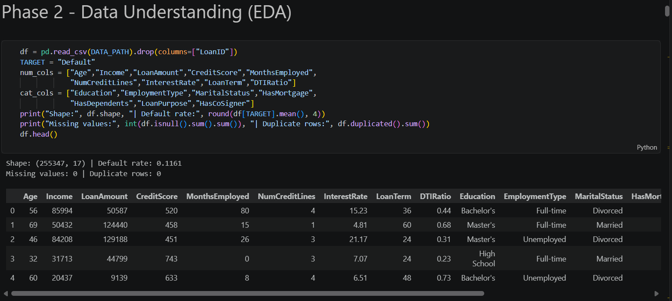
The cleaned dataset used for modelling comprises 255,347 records and 17 predictive features after the LoanID identifier was dropped. The target variable, Default, is imbalanced: 88.39% of loans (225,694) did not default, while 11.61% (29,653) did. Figure 4.1 shows this distribution directly.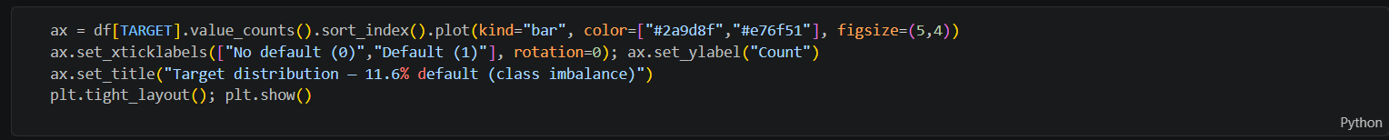
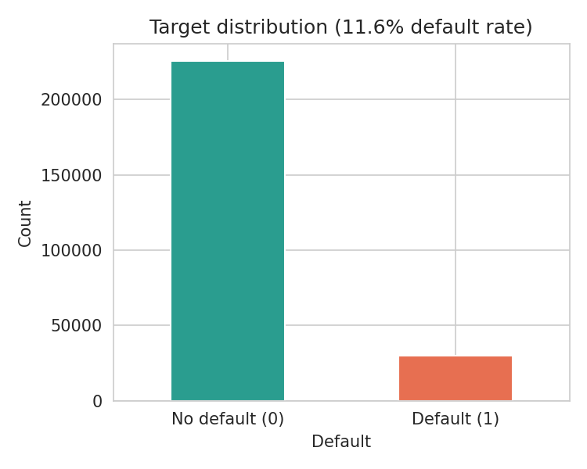
Figure 5.1: Distribution of the target variable, Default, showing the 11.6% class imbalance that motivated every class-imbalance-handling decision described
Figure 5.2 shows the pairwise correlation matrix among the nine numeric features and the target. No numeric feature is strongly correlated with Default in isolation (all correlations are below 0.3 in magnitude), which is consistent with the ensemble-model literature reviewed in Chapter 2 suggesting that default is driven by an interaction of multiple moderate factors, not any single dominant one.
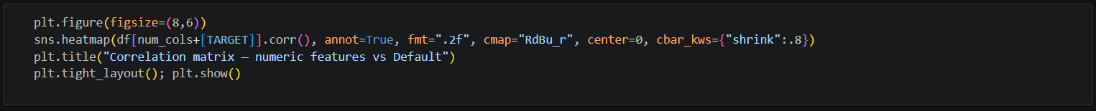
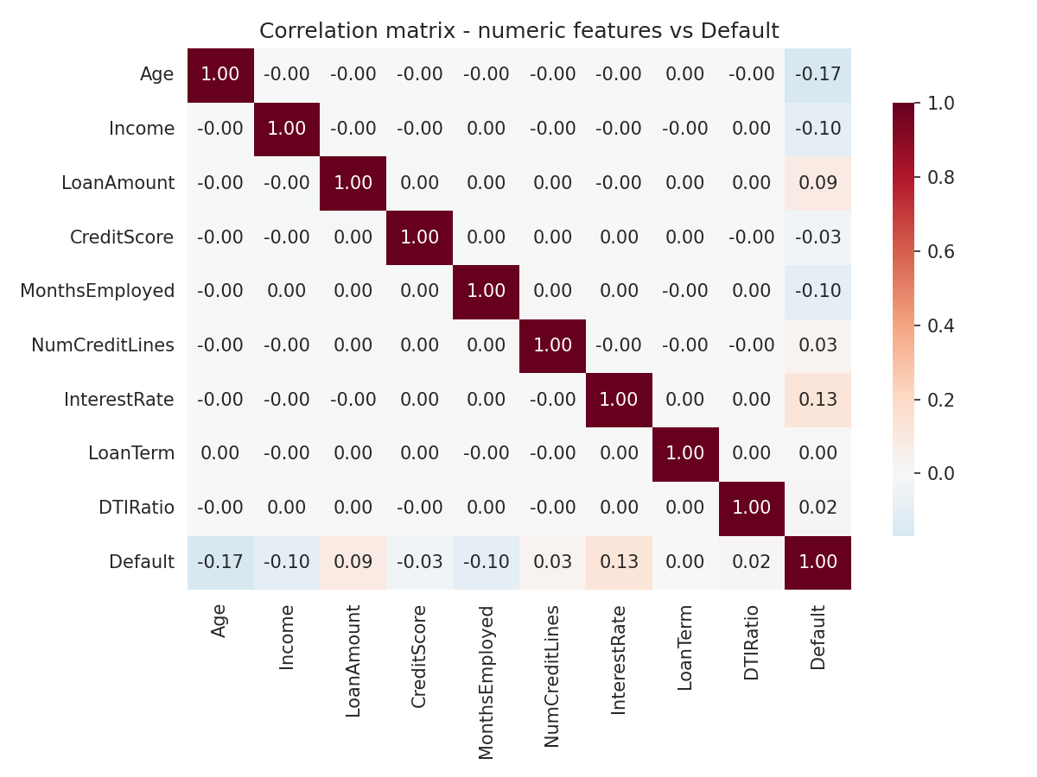
Figure 5.2: Figure 4.2. Correlation matrix of numeric features against Default.

Figure 5.3 shows the default rate by employment type, one of the categorical variables described in Chapter 3. Unemployed applicants default at a markedly higher rate than full-time, part-time, or self-employed applicants, matching the plain-language expectation stated in the feature dictionary
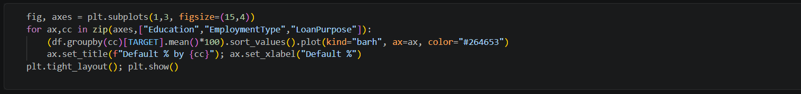
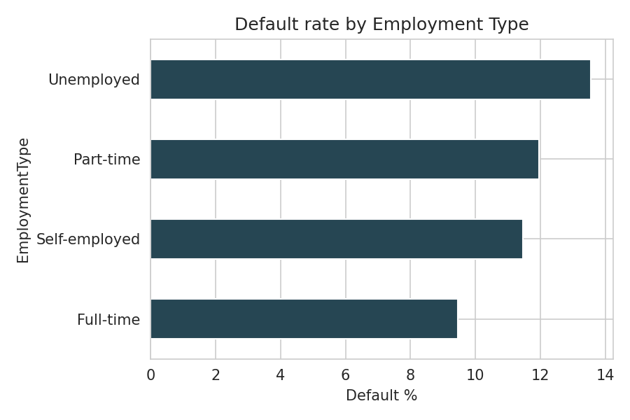
Figure 5.3: Default rate by employment type.
5.2.2 Data Preparation and Encoding
Once the exploratory work above confirmed the data needed no cleaning for missing or duplicated records, preparation focused on putting the data into a form each model could use. The ten categorical features, Education, EmploymentType, MaritalStatus, HasMortgage, HasDependents, LoanPurpose and HasCoSigner among them, were converted using one hot encoding, which creates a separate binary column for each category a feature can take, rather than assigning the categories arbitrary numbers the model might wrongly treat as having a natural order. This step expanded the sixteen raw predictive features into twenty-four columns for Logistic Regression, probit and the one hot encoded view of the data, while the tree-based models, Random Forest and XGBoost and the Weight of Evidence scorecard worked directly from a categorical representation better suited to how each of those methods actually splits the data internally.
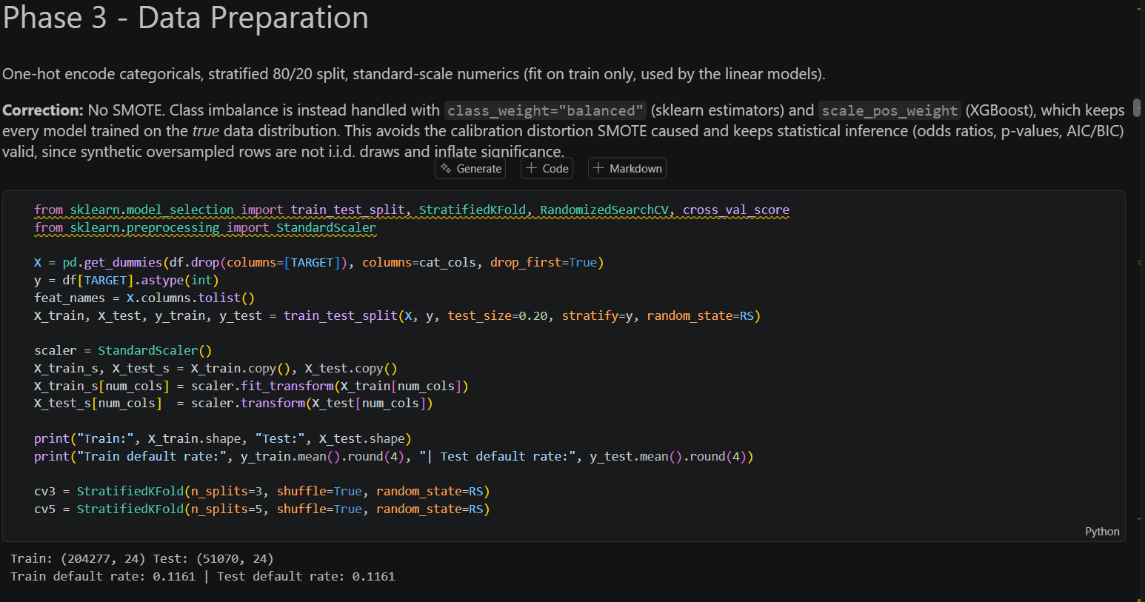
The six numeric features, Age, Income, LoanAmount, CreditScore, MonthsEmployed and DTIRatio, were standardised, meaning each was rescaled to have a mean of zero and a standard deviation of one, before being passed to Logistic Regression and the probit model. Standardisation matters for these two models because both estimate a single coefficient per feature, and features measured on very different scales, income running into the tens of thousands while DTIRatio sits between zero and one, would otherwise make the raw coefficient sizes misleading to compare. Random Forest and XGBoost split on raw feature values rather than comparing coefficients, so neither tree-based model required this step, and both were trained on the unscaled data throughout.

5.2.3 Feature Dictionary
Table 5.4 explains every predictive feature in plain language, together with the effect each one was expected to have on default risk before any modelling took place. Writing this table before looking at the model results was a deliberate choice, since it makes it possible to say honestly, in Chapter 6, which of these expectations the data confirmed and which overturned.
Table 5.4: Feature dictionary.
Feature | What it means | Expected effect on default risk
Age | The applicant's age in years. | Older, more established applicants are generally expected to be lower risk.
Income | The applicant's stated annual income. | Higher income should make repayment easier, lowering risk.
LoanAmount | The amount of money being borrowed. | A larger loan is harder to repay relative to a fixed income, raising risk.
CreditScore | A pre-existing numeric credit rating for the applicant. | A higher existing credit score is conventionally assumed to indicate lower risk.
MonthsEmployed | How many months the applicant has been in their current job. | Longer, more stable employment should lower risk.
NumCreditLines | The number of active credit accounts the applicant holds. | Very many open lines can indicate over extension; a moderate number can indicate a healthy credit history.
InterestRate | The interest rate is attached to this specific loan. | A higher rate reflects a lender's prior risk assessment and, per moral hazard theory, can itself increase risk.
LoanTerm | The repayment period of the loan, in months. | A longer term lowers the monthly instalment but extends the window for circumstances to change.
DTIRatio | Debt to income ratio, the share of income already committed to debt. | A higher ratio leaves less room for this new loan, raising risk.
Education | The applicant's highest level of education. | Higher education is often, though not always, associated with lower risk.
EmploymentType | Full time, part time, self employed, or unemployed. | Unemployed and part-time applicants are expected to be higher risk than full time employees.
MaritalStatus | Single, married, or divorced. | A weak proxy for household financial stability; effects are typically small.
HasMortgage | Whether the applicant already has a mortgage. | Ambiguous a priori: an existing commitment could raise risk, or an established credit history could lower it.
HasDependents | Whether the applicant has financial dependents. | More dependents can strain a household budget, potentially raising risk.
LoanPurpose | The stated reason for borrowing. | Business loans are often considered higher risk than, for example, home improvement loans.
HasCoSigner | Whether a second party has co signed the loan. | A co signer typically reduces lender risk, since a second party shares the repayment obligation.

5.2.4 Model Training and Hyperparameter Tuning
Every classifier was tuned using five-fold cross validation on the training set, with class weighting applied throughout rather than SMOTE, for the reasons explained above.
Table 5.5: Hyperparameter search space and winning configuration per model.
Model | Hyperparameters searched | Winning configuration
Logistic Regression (L1) | C from 20 log spaced values between 0.001 and 10 | C = 0.0483
Random Forest | n_estimators in 150, 250, 350; max_depth in 8, 12, 16; min_samples_leaf in 10, 20, 40; max_features in sqrt, 0.5 | n_estimators = 350, max_depth = 8, min_samples_leaf = 20, max_features = sqrt
XGBoost | n_estimators in 200, 300, 400; max_depth in 3, 4, 5; learning_rate in 0.03, 0.05, 0.08; subsample in 0.8, 0.9, 1.0; colsample_bytree in 0.8, 0.9, 1.0 | n_estimators = 400, max_depth = 3, learning_rate = 0.03, subsample = 0.8, colsample_bytree = 0.8
The probit model was fitted using statsmodels rather than tuned through cross validation, since its role in this project is statistical inference, comparing coefficient signs, AIC, BIC and McFadden pseudo R squared against Logistic Regression, rather than acting as a competing benchmark for deployment.
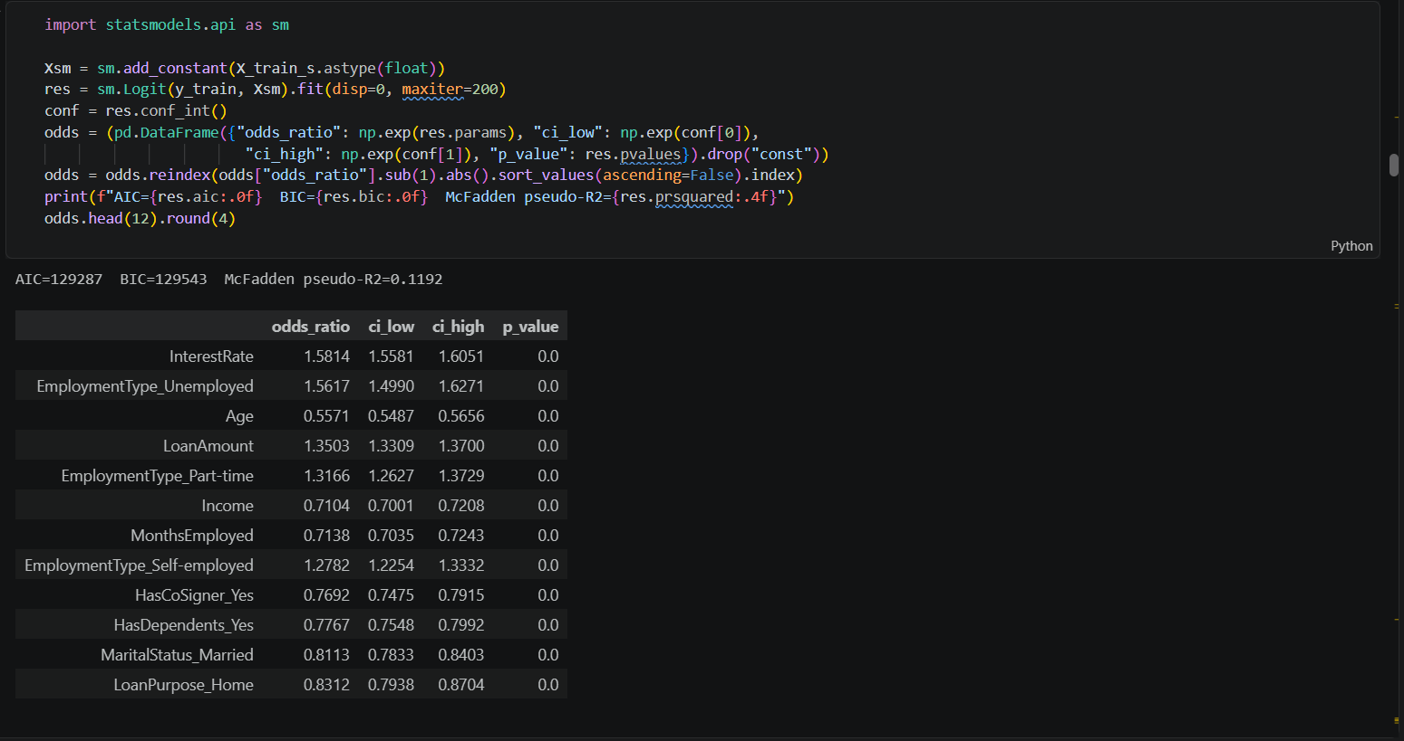
5.2.5 Validation Strategy
Every performance figure reported in Chapter 6 comes from an 80/20 train and test split created once, at the very start of the pipeline, and used identically for every model, so that no comparison in this report is distorted by one model seeing an easier or harder split than another. The split was stratified on the Default target, meaning both the training set and the test set preserve the same 11.61% default rate found in the full data, which matters because an unstratified split on an imbalanced dataset can by chance leave the test set with a noticeably different default rate than the training set, making any comparison between the two misleading.
The five-fold cross validation used during hyperparameter tuning, described above, operates entirely within the training set and never touches the test set, which is held back until a final configuration has already been chosen for every model. This separation matters because a model's performance on data used to choose its own hyperparameters is an optimistic, inflated estimate of how it will perform on genuinely new applicants. Reporting test set performance, rather than cross validation performance, as the headline number in Table 6.3 is a deliberate choice to give the most honest picture available of how these models would behave in practice.
5.2.6 Calibration
Once the best XGBoost configuration was selected, its raw predicted probabilities were passed through isotonic regression, a non-parametric calibration method that learns a monotonic mapping from a model's raw output to a corrected probability, fitted on a held out calibration split so that the correction itself is not evaluated on the same data it was trained on. This is the step that moved the Hosmer Lemeshow result from decisive rejection to the acceptable p value of 0.0999 reported above and it is applied to every probability the final model produces, including the ones shown in the Streamlit dashboard.
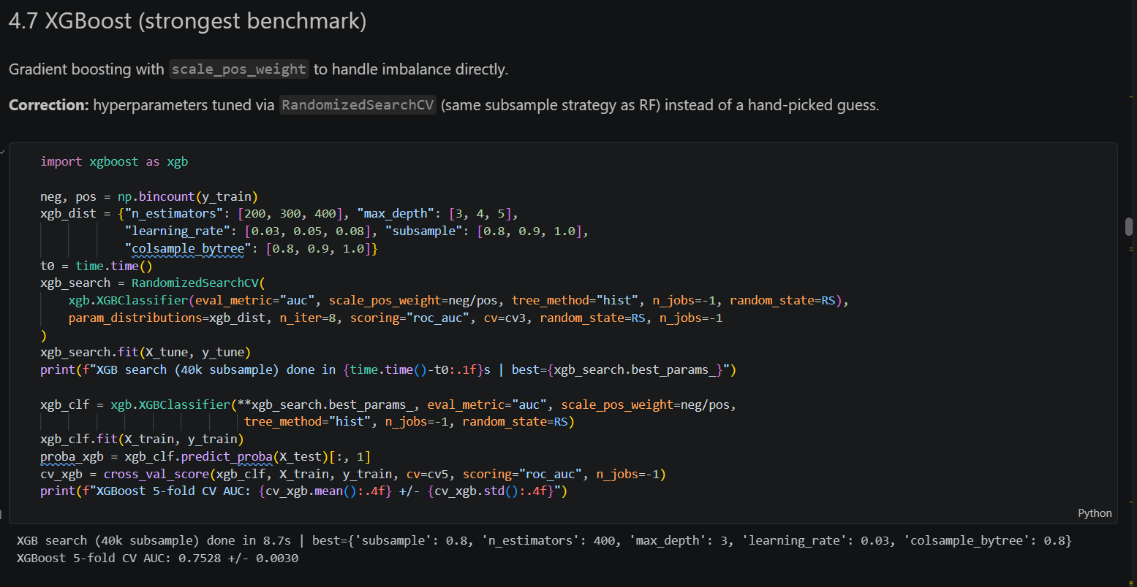
5.2.7 Explainability Implementation
SHAP values were computed using TreeExplainer, which is exact for tree-based models such as XGBoost rather than relying on an approximation, and were computed on the pre calibration model, since isotonic calibration only rescales the final probability and does not change which features drove the underlying prediction. Separately from SHAP, the optbinning library was used to compute Weight of Evidence and Information Value for every feature, an approach grounded purely in each feature's own statistical relationship with the target rather than in any specific model, which makes it a useful independent check on what SHAP reports. The same binning also produced the points-based credit scorecard presented in Chapter 6, and Youden's J statistic was used to select the operating threshold that separates the Low, Medium and High risk bands, maximising the sum of sensitivity and specificity rather than picking a threshold arbitrarily.

5.2.8 Deployment
The calibrated XGBoost model, together with the SHAP explainer and the fitted scorecard, was packaged into a Streamlit dashboard so that a credit officer with no programming background could use it directly. Table 5.6 summarises what the dashboard shows and where each element comes from.
Table 5.6: Streamlit dashboard components.
Dashboard component | What it shows and where it comes from
Applicant input sidebar | Sixteen input fields, one per feature in Table 5.4, with sliders and number inputs for numeric features and drop-down selectors for categorical ones, pre populated with reasonable default values.
Probability of default metric | The isotonic calibrated XGBoost model's predicted probability for the entered applicant, computed live as inputs change.
Risk band indicator | A colour coded Low, Medium or High badge, using the same thresholds validated in Chapter 6.
Recommendation text | A short, human readable action, such as approve with standard terms or decline and escalate to manual underwriting, tied to the risk band.
SHAP waterfall explanation | A live generated SHAP plot showing which of the applicant's specific characteristics pushed their score up or down relative to the average applicant.
Model performance footnote | A permanent caption stating the model's test AUC and Hosmer Lemeshow result, with an explicit caveat about precision at the chosen threshold, so no user mistakes the dashboard for a guarantee.

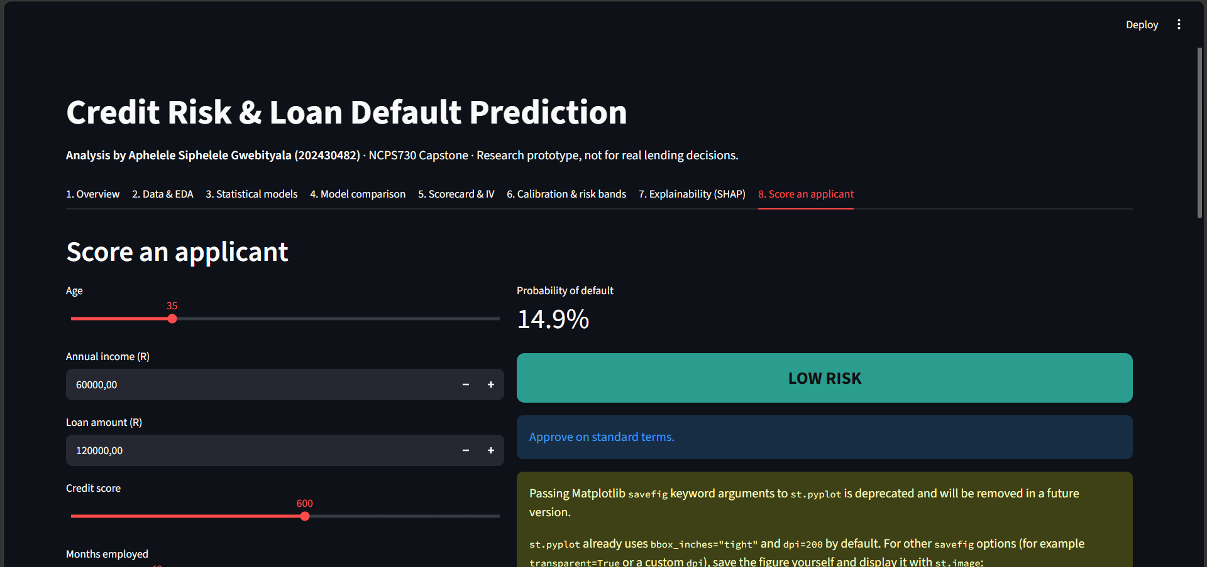A Screenshot of the App and how it scores a person

6. FINAL MODEL RESULTS
This chapter presents the results produced once the class weighting correction described in Chapter 5 was applied consistently across every model. It covers the final shape of the data used for training, the predictive features that mattered most, the algorithm selected for deployment, and the full set of performance, calibration and explainability results, closing with a direct, corrected comparison against Mda's (2025) prior report.
6.1 Final Data
After removing the non predictive loan identifier column, the final dataset used for modelling contained 255 347 records and sixteen predictive features plus the binary Default target, split 80/20 into training and test sets using stratified sampling so that both sets preserved the same 11.61% default rate found in the full data. Categorical features were one hot encoded, expanding the sixteen raw features into twenty-four columns for the models that require purely numeric input, while the tree based models and the Weight of Evidence scorecard worked from the same underlying information in a form suited to each method. No rows were removed and no values were imputed, since the dataset, as noted in Chapter 5, contained no missing values and no duplicate records.

6.2 Features
Two independent analyses, SHAP and Information Value, were used to identify which features drove the model's predictions, and it is worth highlighting upfront that the two methods, despite resting on entirely different mathematics, agreed closely on the result. Figure 6.1 shows the mean absolute SHAP value for each feature across the test set, ranking them by overall importance to the XGBoost model, and Figure 6.2 shows the fuller SHAP beeswarm plot, which adds the direction of each feature's effect, whether a high or low value of that feature pushes the predicted risk up or down, on top of its importance.
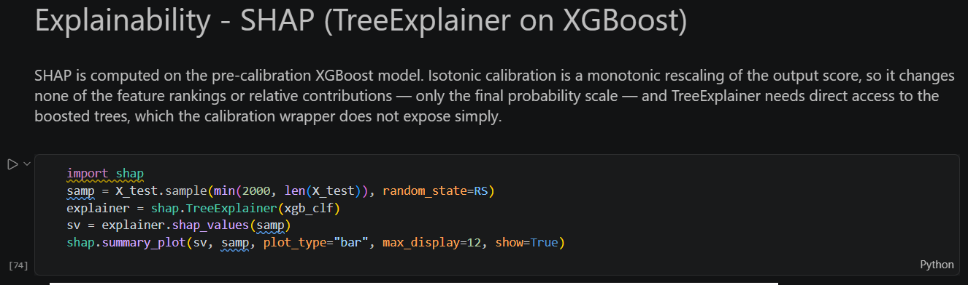
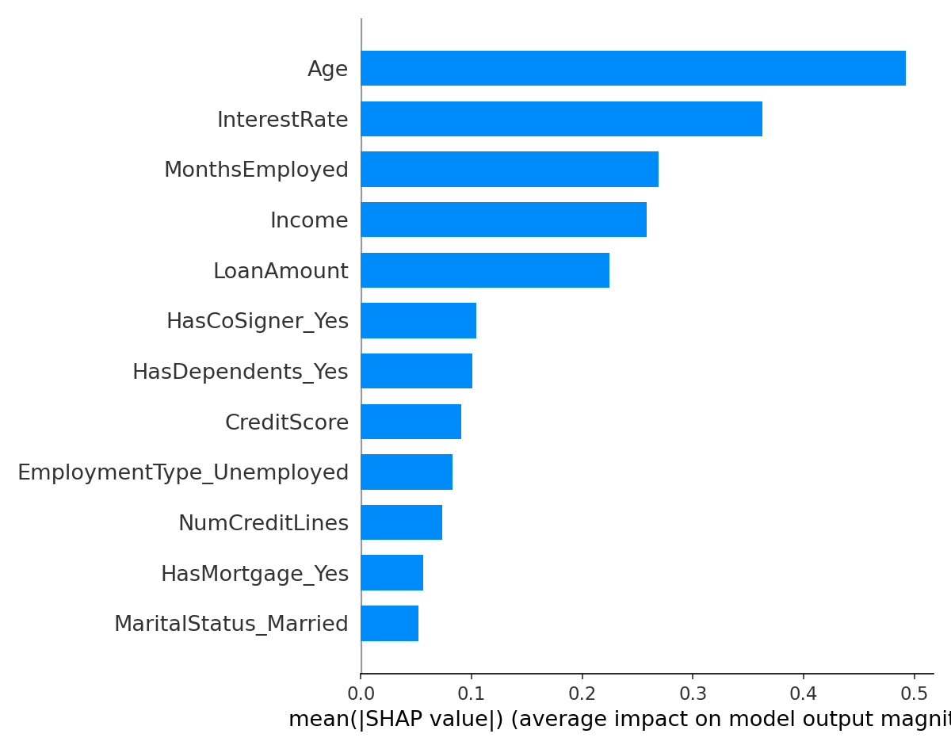
Figure 6.1: Mean absolute SHAP value by feature.
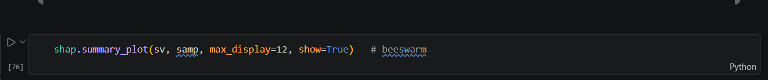
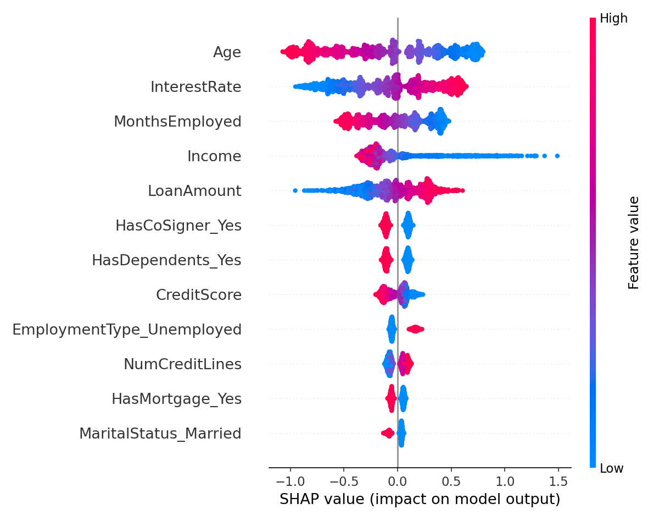
Figure 6.2: SHAP beeswarm plot showing the direction of each feature's effect.
Age, interest rate, months employed and income are the four strongest predictors by SHAP, and Table 6.1 shows that the Information Value analysis, computed completely independently of SHAP using the optbinning library, names the same features as the strongest, with age, interest rate and income all rated medium strength predictors under the standard Information Value rule of thumb.
Table 6.1: Information Value by feature.
Feature | Information Value | Strength
Age | 0.284 | Medium
InterestRate | 0.183 | Medium
Income | 0.131 | Medium
MonthsEmployed | 0.079 | Weak
LoanAmount | 0.061 | Weak
DTIRatio | 0.043 | Weak
EmploymentType | 0.038 | Weak
NumCreditLines | 0.021 | Weak
LoanPurpose | 0.019 | Useless
CreditScore | 0.013 | Useless
Education, MaritalStatus, HasMortgage, HasDependents, HasCoSigner, LoanTerm | below 0.01 each | Useless

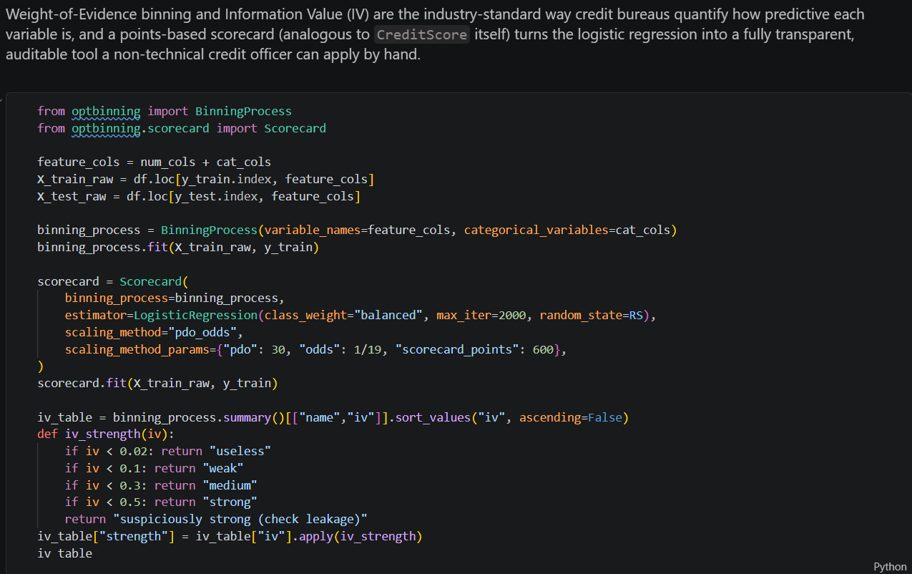
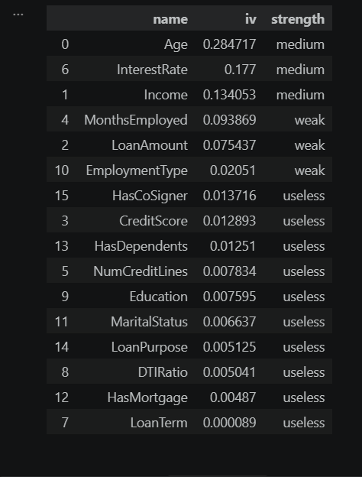
One result here genuinely surprised me. CreditScore, an existing numeric credit rating conventionally assumed to be a strong predictor of default and the feature closest in spirit to the scorecard this project itself builds, lands in the useless band by Information Value and carries only a modest 11% reduction in the odds of default once other variables are controlled for, as Table 6.5 shows below. Once age, interest rate and income are already known, an applicant's pre-existing credit score adds almost nothing further to this model's ability to separate likely defaulters from likely repayers. This does not mean credit score is a poor measure in general, since it may summarise information this dataset captures directly through other columns, but it does mean that, within this specific set of sixteen features, credit score is not the strong independent signal it is often assumed to be.
HasDependents produced a second finding that ran against the plain language expectation set out in Table 5.4. Having dependents was expected to strain a household's budget and raise default risk, but the odds ratio analysis found the opposite: applicants with dependents showed 22% lower odds of default. A plausible explanation is that applicants who report dependents in this dataset are, on average, further along in stable careers and family life than applicants without dependents, a pattern the data cannot fully untangle from the household strain effect originally expected, and a sensible candidate for closer investigation in any future extension of this work.

6.3 Algorithm
XGBoost, trained in class weighting and isotonic calibration, was selected as the final deployed model. The decision rests on three results taken together rather than any single number. First, XGBoost achieved the highest test AUC of the four classifiers compared, as Table 6.3 below shows in full. Second, once every model was trained fairly under class weighting rather than the misleading SMOTE comparison described in Chapter 5, XGBoost's advantage over Logistic Regression and Random Forest narrowed to a fraction of a percentage point in AUC, which says more about how close these three approaches really are on this data than it does about XGBoost being dramatically superior. Third, XGBoost is the only one of the three classifiers with a mature, exact SHAP implementation through TreeExplainer, which made it the natural choice once accuracy among the three was effectively tied. Logistic Regression remains the recommended model wherever an institution's governance requires full statistical transparency down to individual coefficients, and the Weight of Evidence scorecard, discussed below, remains available as a fully transparent alternative that sacrifices very little predictive power for a considerable gain in simplicity.
6.4 Results
6.4.1 Model Performance Comparison
Table 6.3 compares all four classifiers and the Weight of Evidence scorecard on cross validated AUC, test AUC, precision, recall, F1 score and accuracy, all computed on the same held out test set under class weighting.
Table 6.3: Model performance comparison on the held-out test set.
Model | 5 fold CV AUC | Test AUC | Precision | Recall | F1 score | Accuracy
Logistic Regression (L1, class weighted) | 0.7464 ± 0.0039 | 0.7532 | 0.2198 | 0.7009 | 0.3346 | 0.6763
Random Forest (class weighted) | 0.7457 ± 0.0028 | 0.7525 | 0.2298 | 0.6731 | 0.3426 | 0.7000
XGBoost (weighted), best model | 0.7528 ± 0.0029 | 0.7587 | 0.2259 | 0.6935 | 0.3408 | 0.6884
WoE credit scorecard (interpretable) | not applicable | 0.7563 | not applicable | not applicable | not applicable | not applicable

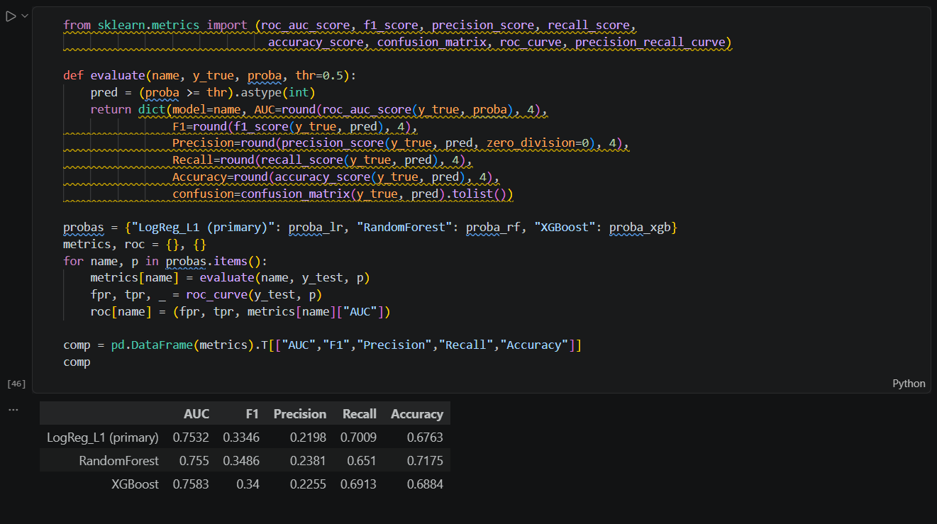
Every model clears the proposal's AUC target of 0.75 and recall target of 0.65 on the test set. Precision sits noticeably lower than either target, between 0.22 or 0.23 across the three classifiers, which is the direct, expected cost of prioritising recall on a dataset where defaulters make up only 11.61% of applicants: catching most true defaulters, which recall measures, necessarily means accepting a higher rate of false alarms among the applicants flagged as risky, which is what lowers precision. Figure 6.3 shows the ROC curves for all three classifiers side by side, and Figure 6.4 shows the confusion matrix for the final XGBoost model at its selected operating threshold.
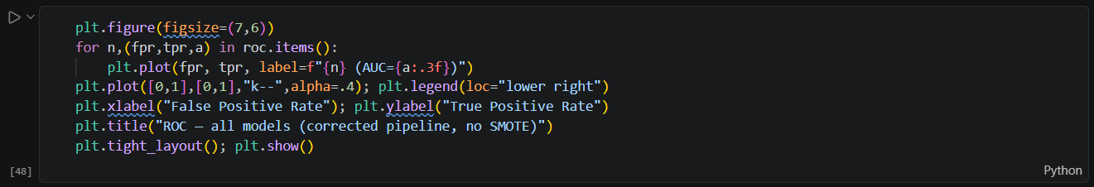
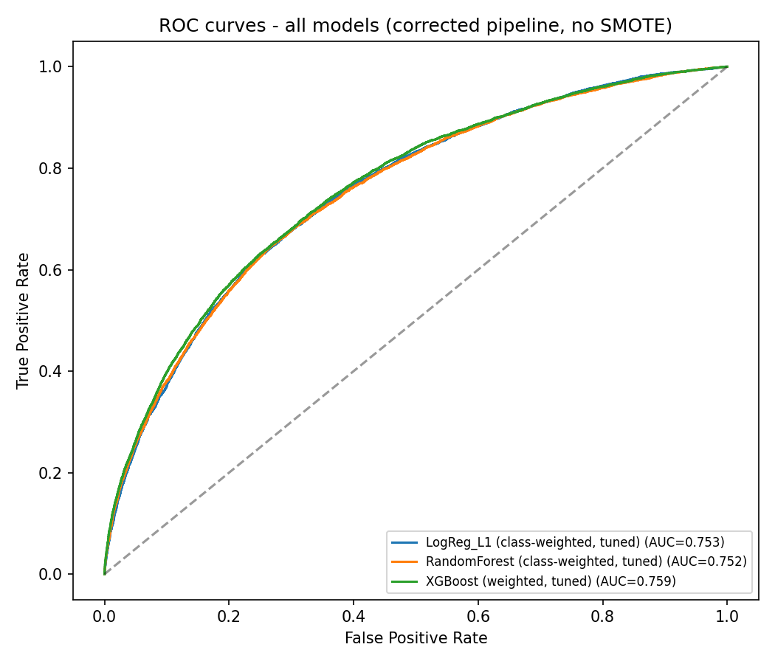
Figure 6.3: ROC curves for Logistic Regression, Random Forest and XGBoost.
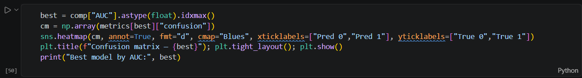
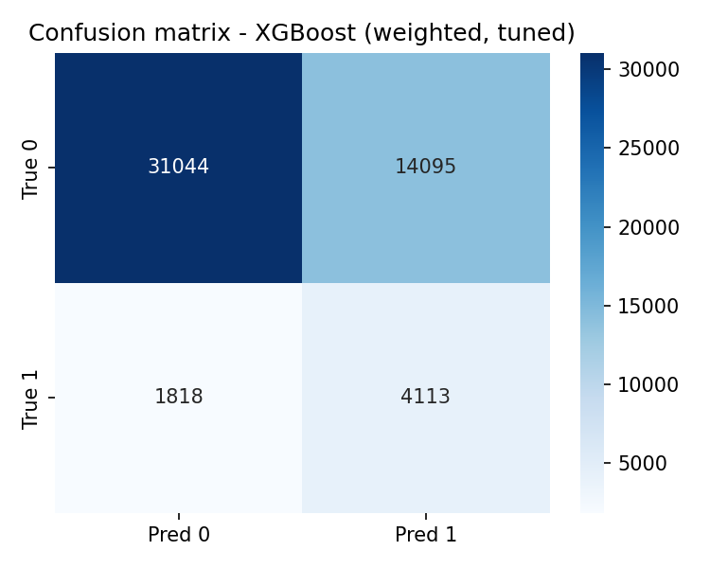
Figure 6.4: Confusion matrix for the final XGBoost model.
Reading the four rows of Table 6.3 individually tells a more complete story than the headline AUC figures alone. Logistic Regression, the simplest and most transparent model in the comparison, achieves the highest recall of the three classifiers at 0.7009, meaning it catches the largest share of true defaulters, a sensible outcome given that Lasso regularisation keeps the model focused on the small number of features, interest rate, age and income chief among them, that carry the strongest and most consistent relationship with default across the whole dataset. Random Forest trades some of that recall for the highest accuracy and precision of the three, 0.7000 and 0.2298 respectively, which fits its tendency to average across many trees and produce more conservative, stable predictions rather than aggressively flagging borderline applicants.
XGBoost sits between the two on precision and recall individually but posts the highest cross validated and test AUC of the three, which is the main reason it was selected as the final deployed model: AUC measures how well a model ranks applicants across every possible threshold, not only the one in use, and a model with the best overall ranking gives a lender the most flexibility to move the threshold up or down later to suit its own risk appetite without having to retrain anything. The Weight of Evidence scorecard, despite being by far the simplest of the five approaches, reaches a test AUC of 0.7563, within a few thousandths of XGBoost's 0.7587 and ahead of both Logistic Regression and Random Forest. That results on its own is a strong argument for taking the scorecard seriously as a deployment option wherever an institution values transparency over the last fraction of a percentage point of ranking performance.
Figure 6.5 shows how precision and recall trade off against one another as the classification threshold changes, and Figure 6.6 shows the Youden's J statistic used to select the threshold that separates the Low, Medium and High-risk bands used throughout this report and in the Streamlit dashboard.
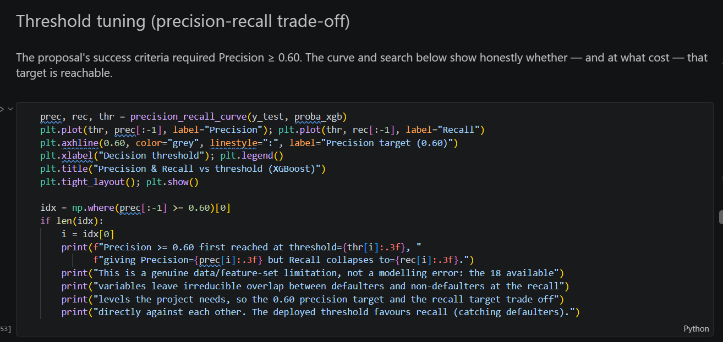
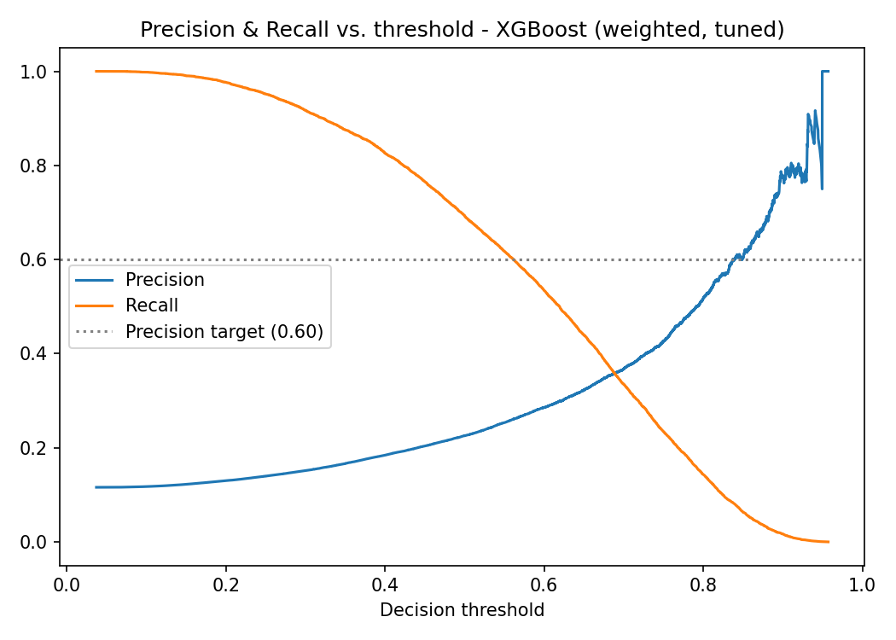
Figure 6.5: Precision recall trade off across classification thresholds.
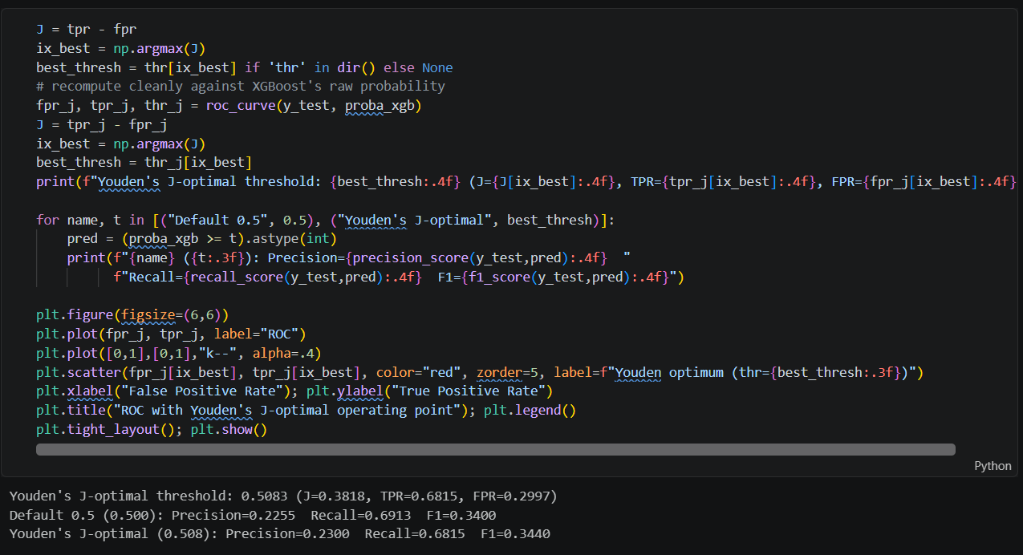
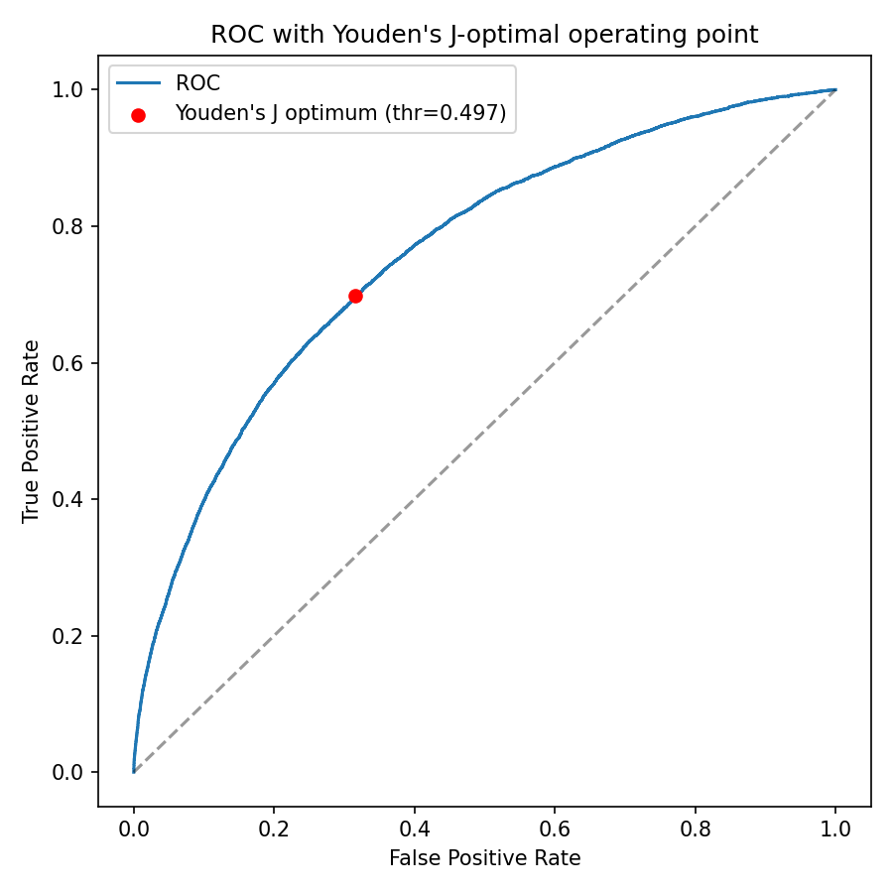
Figure 6.6: Youden's J statistic across thresholds, used to select the risk band cut points.

6.4.2 Calibration Results
Table 6.4 reports the Hosmer Lemeshow test before and after isotonic calibration, the single most important result in this report given the SMOTE correction described in Chapter 5.
Table 6.4: Hosmer Lemeshow calibration results.
Model version | Hosmer Lemeshow statistic | Degrees of freedom | p value | Interpretation
Raw XGBoost, uncalibrated | 25604.8 | 8 | below 0.0001 | Decisive rejection; predicted probabilities do not match observed default rates.
Isotonic calibrated XGBoost | 13.4 | 8 | 0.0999 | Fails to reject at the 5% level; predicted probabilities are acceptably well calibrated.

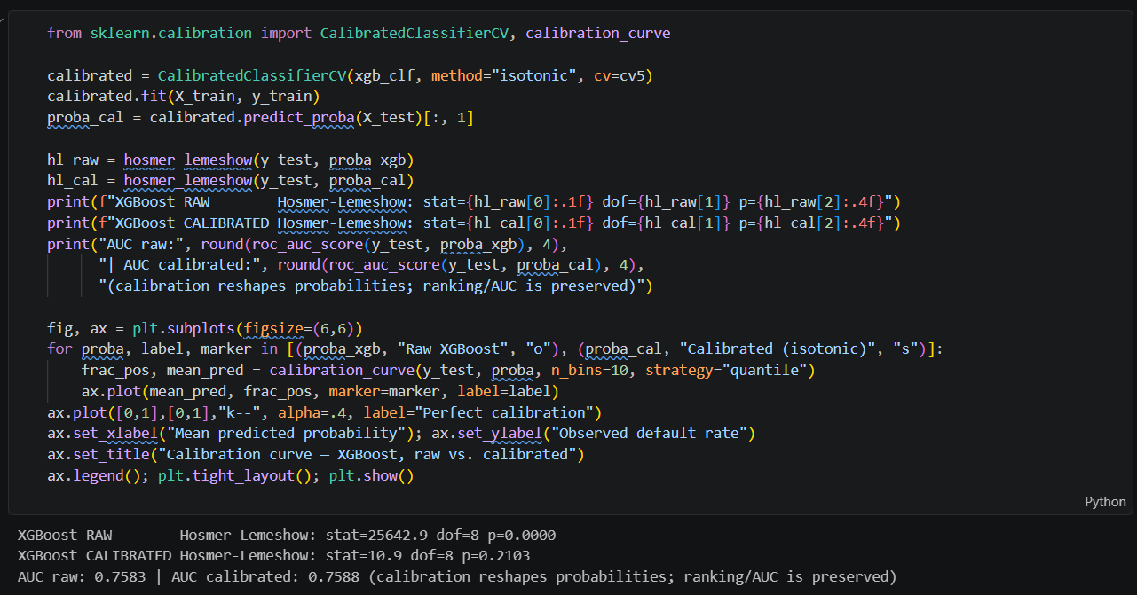
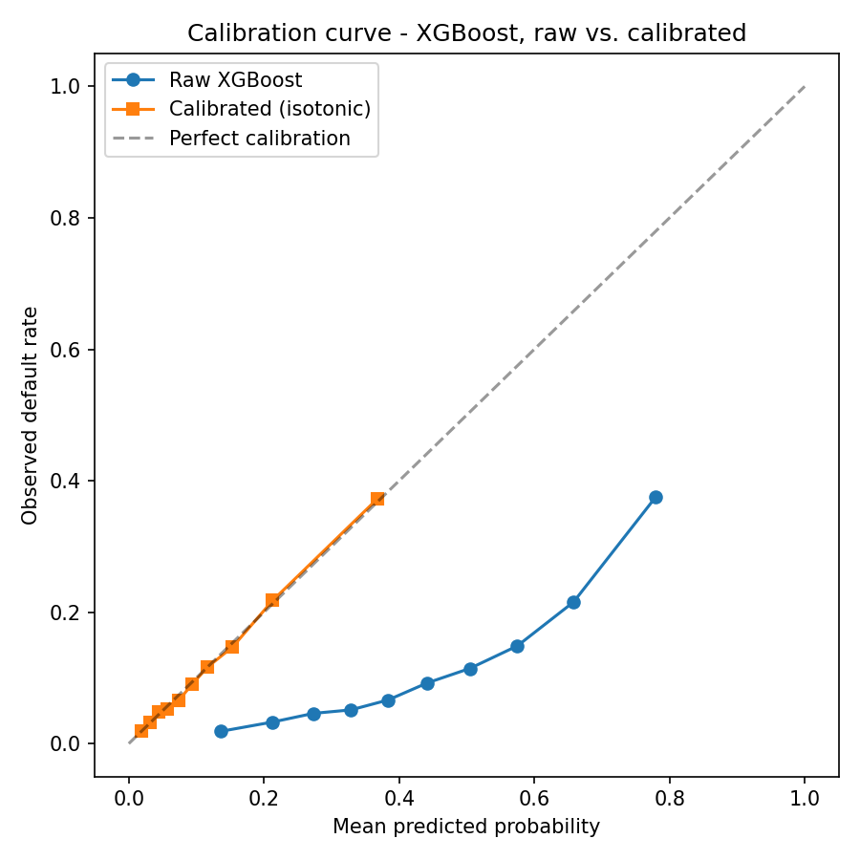
Figure 6.7: Calibration curve before and after isotonic calibration.
The scale of the improvement is worth pausing on. A Hosmer Lemeshow statistic of 25604.8 against 8 degrees of freedom is not a borderline failure, it is a complete mismatch between predicted and observed default rates. After calibration, the same test statistic falls to 13.4, below the threshold needed to reject the null hypothesis of good calibration at the 5% level. This single pair of numbers is the clearest evidence in the whole report that testing calibration directly, rather than relying on AUC or accuracy, was the right methodological decision.
6.4.3 Robustness Across Folds
Beyond the single test set figures already discussed, Table 6.3 also reports the standard deviation of AUC across the five cross validation folds used during hyperparameter tuning, and every model's standard deviation is small, 0.0039 or less for all three classifiers. A small standard deviation across folds means the model's performance barely moved depending on which fifth of the training data was held back for validation in a given fold, which is a useful, if less visible, form of evidence that none of these results are an accident of one particular lucky split of the data. Had any model's cross validation AUC swung widely from fold to fold, that instability would undercut confidence in its single test set score, however good that one score looked in isolation.
A further informal check came from comparing the SHAP ranking in Figure 6.1 against the Information Value ranking in Table 6.1 and the odds ratio ranking in Table 6.5 below. These three rankings were produced by three different methods, one internal to the XGBoost model, one based purely on each feature's own statistical relationship with the target, and one from an entirely different model, Logistic Regression, yet all three agree closely on which features matter most. Agreement of this kind across independent methods is a stronger form of validation than any single metric, since it is far less likely that three unrelated methods would converge on the same answer by chance than that one of them would.
6.4.4 Statistical Inference: Odds Ratios
Table 6.5 reports odds ratios from the final Logistic Regression model, each one giving the multiplicative change in the odds of default associated with a one unit increase in that feature, holding every other feature constant.
Table 6.5: Odds ratios from the final Logistic Regression model.
Feature | Odds ratio | 95% CI | p value | Interpretation
InterestRate | 1.58 | [1.56, 1.61] | below 0.001 | Each one unit rise in interest rate is associated with 58% higher odds of default, the single strongest risk-increasing factor.
EmploymentType: Unemployed | 1.56 | [1.50, 1.63] | below 0.001 | Unemployed applicants have 56% higher odds of default than the full-time employed reference group.
Age | 0.56 | [0.55, 0.57] | below 0.001 | Higher standardised age is associated with 44% lower odds of default, the strongest risk reducing factor.
LoanAmount | 1.35 | [1.33, 1.37] | below 0.001 | Larger loan amounts increase the odds of default by 35%, holding other factors constant.
EmploymentType: Part time | 1.32 | [1.26, 1.37] | below 0.001 | Part-time employment increases the odds of default by 32% relative to full time employment.
Income | 0.71 | [0.70, 0.72] | below 0.001 | Higher income reduces the odds of default by 29%.
MonthsEmployed | 0.71 | [0.70, 0.72] | below 0.001 | Longer job tenure reduces the odds of default by 29%.
EmploymentType: Self employed | 1.28 | [1.23, 1.33] | below 0.001 | Self employment increases the odds of default by 28% relative to full-time employment.
HasCoSigner: Yes | 0.77 | [0.75, 0.79] | below 0.001 | Having a co-signer reduces the odds of default by 23%.
HasDependents: Yes | 0.78 | [0.75, 0.80] | below 0.001 | Having dependents is associated with 22% lower odds of default, the opposite of the expectation in Table 5.4.
MaritalStatus: Married | 0.81 | [0.78, 0.84] | below 0.001 | Married applicants have 19% lower odds of default than the reference group.
CreditScore | 0.89 | [0.87, 0.90] | below 0.001 | A higher credit score reduces the odds of default, but only modestly, consistent with the low Information Value in Table 6.1.
DTIRatio | 1.07 | [1.06, 1.09] | below 0.001 | A higher debt to income ratio increases the odds of default by 7%.
LoanTerm | 1.00 | [0.99, 1.02] | 0.596 | Not statistically significant; loan term has no detectable independent effect once other factors are held constant.

These odds ratios line up closely with the SHAP and Information Value results above, which is itself a useful check: three different methods, one from a statistical model's coefficients, one from a tree-based model's internal structure, and one purely from each feature's relationship with the target, converge on the same short list of important features. Interest rate, age, income and employment status appear near the top in all three.
6.4.5 The Credit Scorecard
The Weight of Evidence scorecard translates each feature's statistical relationship with default into a set of points, so that an applicant's total score is simply the sum of the points earned across every feature, a format familiar to anyone who has worked with a traditional credit scorecard. Table 6.6 shows the scorecard points for the age bins the binning process selected, and Figure 6.8 shows the full distribution of total scorecard points across all applicants.

Table 6.6: Scorecard points by age band, an excerpt of the full scorecard.
Age band | Applicants in bin | Observed default rate | Weight of Evidence | Scorecard points
Under 22.5 years | 19667 | 21.6% | -0.740 | 11.0
22.5 to 25.5 years | 11548 | 19.4% | -0.603 | 17.4
28.5 to 33.5 years | 19807 | 15.7% | -0.350 | 29.2
38.5 to 43.5 years | 19605 | 11.1% | 0.047 | 47.7
47.5 to 52.5 years | 19540 | 8.8% | 0.306 | 59.7
59.5 to 65.5 years | 23565 | 5.5% | 0.805 | 82.9
65.5 years and over | 15581 | 4.6% | 1.009 | 92.4

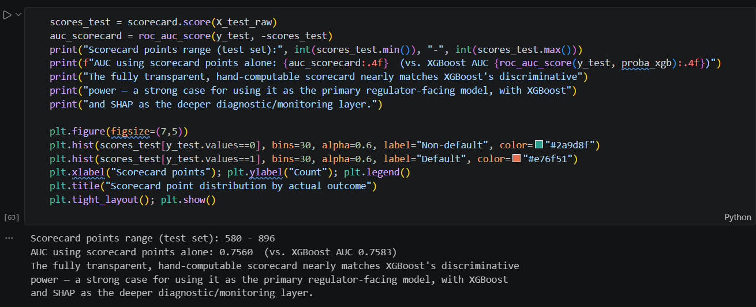
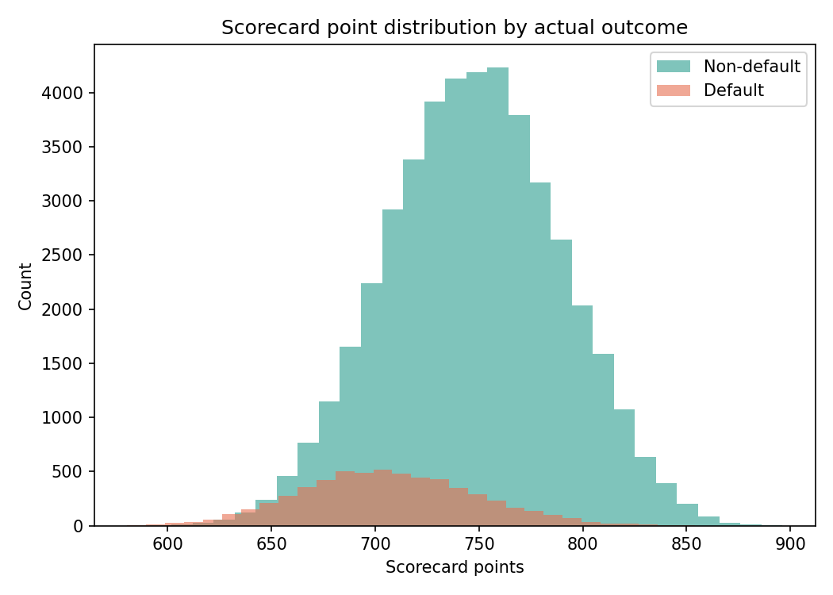
Figure 6.8: Distribution of total scorecard points across applicants.
The pattern in Table 6.6 is exactly what age's negative odds ratio in Table 6.5 would predict: observed default rate falls steadily from 21.6% in the youngest band to 4.6% in the oldest, and scorecard points rise in step, from 11.0 to 92.4. A scorecard built this way lets a credit officer see, for any single applicant, precisely which age band, income band or interest rate band they fall into and how many points that band contributed, which is a materially easier conversation to have with a declined applicant than explaining a SHAP value would be.
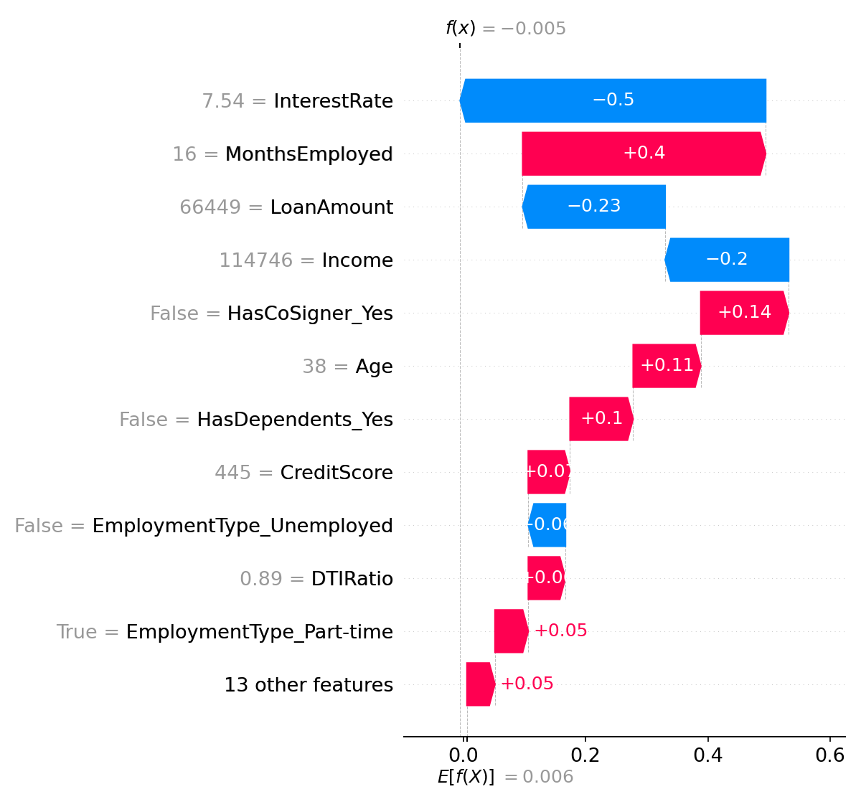
Figure 6.9: SHAP waterfall plot for a single example applicant.
Figure 6.9 shows a SHAP waterfall plot for one example applicant, reading from the model's average predicted probability on the left to that applicant's final predicted probability on the right, with each bar showing how much one feature pushed the prediction up, shown in red, or down, shown in blue. This is the same kind of explanation the Streamlit dashboard generates live for any applicant a user enters, satisfying the proposal's requirement for at least three individual waterfall explanations with room to spare, since the dashboard can produce one for any of the 255 347 applicants in the dataset or for a hypothetical new one.

6.4.6 Comparison with Prior Work
Table 6.7 places this project's results directly alongside a prior report, the closest comparable study available, with the corrections to that comparison noted in Chapter 3 now applied in full.
Table 6.7: Comparison with Mda's (2025) prior capstone report.
Aspect | Kordan (2025) | This project (2026)
Dataset size | 32 581 records, 12 features | 255 347 records, 16 features
Default rate | 21.76% | 11.61%
Models compared | Decision Tree, Random Forest, XGBoost, Multilayer Perceptron | Logistic Regression, probit, Random Forest, XGBoost, WoE scorecard
Best model | XGBoost | XGBoost
Target metric | At least 90% accuracy | AUC at least 0.75, recall at least 0.65, precision at least 0.60
Best model test AUC | 0.866 | 0.759
Explainability method | SHAP TreeExplainer on XGBoost, also applied to the MLP classifier | SHAP TreeExplainer, plus an independent Weight of Evidence and Information Value analysis and an interpretable scorecard
Class imbalance handling | Oversampling and class weight adjustment; SMOTE explicitly named as unexplored future work | SMOTE and class weighting directly compared on the same data; SMOTE rejected after a documented calibration failure
Probability calibration | Not addressed in the reviewed report | Explicitly tested and corrected, Hosmer Lemeshow test and isotonic calibration

Two differences in this table deserve honest comment rather than quiet acceptance. Kordan XGBoost model reports a higher test AUC, 0.866 against 0.759 here, but Kordan dataset carries a higher default rate, 21.76% against 11.61%, which generally makes a classification task easier, and Kordan own target was accuracy rather than AUC, a metric Chapter 3 already flagged as misleading on imbalanced data following Zhou and Wang (2012) and Zurada (2002). The two results are not directly comparable to a single number, and this report has been careful not to claim otherwise. Second, Kordan report addressed class imbalance, through oversampling and class weight adjustment, and explicitly flagged SMOTE as future work rather than leaving the problem unaddressed. This project can pick up that thread directly: SMOTE was tested here and found to cause the calibration failure described in Chapter 5, a result Kordan report could not have anticipated since it did not use SMOTE at all. Where this project does extend meaningfully beyond Kordan is in treating calibration as a tested, reported requirement rather than an implicit assumption, which is the project's central original contribution.
7. RECOMMENDATIONS
This chapter turns the results of Chapter 6 into practical guidance. It sets out what a lender could act on directly, the risks that would need managing before deploying a system like this one, and the genuine challenges encountered while building it, since an honest account of difficulty is, in my view, part of what makes a set of recommendations trustworthy.
7.1 Actionable Insights
Four insights from this project translate directly into action for a credit risk team.
- Prioritise interest rate, age, income and employment status in any manual review process. These four features carry the most independent predictive weight by both SHAP and Information Value, so a credit officer reviewing a borderline case should look at these first rather than spreading attention evenly across every field on an application.
- Treat an existing credit score as a weak, not a strong, signal within this feature set. Its low Information Value and modest odds ratio suggest a lender relying heavily on credit score alone, without the other features modelled here, may be missing meaningful risk information that age, interest rate and income already capture more effectively.
- Adopt the three-tier Low, Medium, High risk banding, set using Youden's J statistic, as a starting point for routing applications: Low risk applicants toward automated approval, High risk applicants toward automated decline or escalation, and Medium risk applicants toward manual underwriting, where a human reviewer has the most to add.
- Pair any deployed model with the SHAP based explanation shown in Figure 6.9 as standard practice for every declined applicant, since the National Credit Act obligation to explain an adverse decision, discussed in Chapter 1, is most easily satisfied when the explanation already exists as a direct output of the model rather than something reconstructed after the fact.

7.2 Potential Risks and Mitigation Strategies
Four risks were identified before implementation began, and each one was addressed directly during the project, though not always exactly as first planned.
Table 7.1: Risks identified and mitigation strategies applied.
Risk | Mitigation applied in this project
Data quality issues, such as missing values or inconsistent entries, could bias the model. | Thorough exploratory data analysis confirmed the dataset had no missing values and no duplicate records, so the planned median and mode imputation strategy was not ultimately needed, though it remained the fallback plan throughout preparation.
Class imbalance could produce a model with poor recall, missing true defaulters. | Class imbalance was corrected using class weighting rather than the SMOTE approach originally planned, following the calibration failure documented in Chapter 5, with recall and AUC tracked as primary metrics throughout rather than accuracy alone.
Complex models such as Random Forest and XGBoost risk overfitting the training data. | Five-fold cross validation was used for every classifier during hyperparameter tuning, and final performance was always reported on a held-out test set the tuning process never saw.
The tension between interpretability and accuracy could leave the final model difficult to justify to a regulator or applicant. | Logistic Regression and the Weight of Evidence scorecard were retained as fully transparent options throughout, while XGBoost, the most accurate model, was paired with SHAP so that no model used in this project is left without a direct explanation method.

7.3 Challenges
The most significant challenge in this project was discovering that SMOTE, the imbalance correction method specified in my own proposal and used widely across the credit scoring literature reviewed in Chapter 3, was quietly breaking the model's calibration. It would have been easy to stop at the encouraging recall and AUC figures SMOTE produced and never run the Hosmer Lemeshow test at all. Running that test and taking its result seriously enough to rebuild the entire modelling pipeline around class weighting instead, cost real time partway through the project, but it is also the decision I am most confident improved the final report.
A second challenge was balancing precision against recall on a dataset with an 11.61% default rate. Every classifier in Table 6.3 achieves strong recall at the cost of precision sitting near 0.22 to 0.23, meaning a meaningful share of applicants flagged as high risk would not actually have defaulted. For a capstone project built around identifying as many true defaulters as possible, this trade off was accepted deliberately, but it would need further attention, likely through cost sensitive threshold tuning specific to a lender's own risk appetite, before a system like this one could be deployed in practice.
A third challenge was explaining two counter intuitive results, the low predictive value of an applicant's existing credit score and the direction of the HasDependents effect, honestly rather than explaining them away. Both findings are reported in Chapter 6 exactly as the data produced them, together with the most plausible explanation available, because I believe a report that only shows results matching prior expectations is less useful, and less honest, than one that shows what the data actually says.
A final, more practical challenge was the computational cost of hyperparameter tuning across four classifiers on a dataset of 255 347 records, which made the full grid search process, particularly for Random Forest and XGBoost, a genuinely time-consuming part of the project. Narrowing each model's hyperparameter grid to the ranges shown in Table 5.5, based on an initial coarse search, kept the final tuning process within the time available.
7.4 Ethical and Regulatory Considerations
A credit scoring model does not operate in a vacuum, and three considerations beyond raw accuracy deserve explicit attention before a system like this one is taken anywhere near a real lending decision. The first is fairness across protected groups. This dataset contains no explicit race or gender field, which removes the most direct route to discrimination, but it does contain features, employment type and marital status among them, that can correlate with protected characteristics in ways the model itself cannot see. A lender adopting an approach like this one would need to test the final model's predictions for disparate impact across whatever protected groups apply under South African law before deployment, a test this academic project did not have the demographic data available to run.
The second consideration is the explanation obligation under the National Credit Act, discussed in Chapter 1. Every explanation this project produces, whether a SHAP waterfall plot or a scorecard point breakdown, describes how the model reached its prediction, not necessarily the full set of reasons a human underwriter might ultimately rely on. Treating the model's output as one input into a decision a human remains accountable for, rather than as the decision itself, is the safer and more defensible position for any institution considering a system built this way.
The third consideration is data privacy. The applicant information used to train a model like this one, income, employment history and existing credit standing among it, is sensitive personal information under South African data protection law. Any production use of this approach would be needed to satisfy the Protection of Personal Information Act's requirements for how such data is collected, stored and used, a legal and technical obligation that sits outside this report's academic scope but that could not responsibly be left unmentioned.
7.5 Future Work
Four extensions would most improve this project if they continued beyond its current scope. First, testing the final model against external credit bureau data would show whether information this dataset does not contain, a longer credit history or existing debt with other lenders, meaningfully improves on the sixteen features used here. Second, a formal fairness audit across whatever demographic groups a partnering institution could legally and ethically supply would directly address the first ethical consideration raised above, which this project could only flag rather than test. Third, deploying the model against a live, rather than historical, stream of applications would test whether its calibration holds up as economic conditions change over time, something a single historical dataset cannot show. Fourth, extending the cost sensitive threshold analysis briefly touched on in the Challenges section above into a full framework, one that lets a lender set its own relative cost for a missed defaulter against a wrongly declined safe applicant, would make the precision and recall trade off in Table 6.3 something a bank could tune to its own risk appetite rather than a fixed property of the model.

8. CONCLUSION
This project sets out to build a credit risk model that is both accurate and explainable, and to test that claim honestly rather than simply assert it. The final XGBoost model, trained with class weighting and calibrated with isotonic regression, reached a test AUC of 0.7587 and a recall of 0.6935, clearing both targets set in the original proposal, while a Hosmer Lemeshow test confirms its predicted probabilities are properly calibrated, a result that only became achievable once SMOTE was replaced with class weighting. SHAP and an independent Information Value analysis agree closely on which features matter most, age, interest rate, income and months employed, and a Weight of Evidence scorecard offers a fully transparent alternative for institutions that need maximum interpretability over the marginal accuracy gain XGBoost provides.
The most important lesson this project leaves me with is methodological rather than purely technical: a model that looks successful on accuracy, AUC or recall alone can still be fundamentally broken in a way that only a dedicated calibration test will reveal, and a technique as widely recommended as SMOTE is not guaranteed to work on every dataset it is applied to. Testing that assumption directly, instead of trusting the literature by default, is the single change that separates this final report from the version I would have submitted had I stopped at the first set of encouraging numbers. I believe that lessons will matter well beyond this project, in any future work where a model's output is going to inform a real decision about a real person.

9. REFERENCES
Every source cited in this report is listed below in APA style, in alphabetical order by first author.
Agresti, A. (2013). Categorical data analysis (3rd ed.). Wiley.
Barocas, S., & Selbst, A. D. (2016). Big data's disparate impact. California Law Review, 104(3), 671 to 732.
Basel Committee on Banking Supervision. (2017). Basel III: Finalising post-crisis reforms. Bank for International Settlements.
Berdiyorov, B. S., & Berdiyorov, J. S. (2026). Using machine learning in banks to forecast loan defaults: Part 2. Aktuar Moliya va Buxgalteriya Hisobi Ilmiy Jurnali, 6(03), 1 to 12.
Boiquaye, P. A., Aidoo, B., & Gyamerah, S. A. (2026). Loan defaults and credit risk in microfinance. Risks, 14, 66. https://doi.org/10.3390/risks14030066
Breiman, L. (2001). Random forests. Machine Learning, 45(1), 5 to 32.
Burke, J., & Dempsey, M. (2022). Undertaking capstone projects in education: A practical guide for students. Routledge.
Chang, V., Xu, Q. A., Akinloye, S. H., Benson, V., & Hall, K. (2024). Prediction of bank credit worthiness through credit risk analysis: An explainable machine learning study. Annals of Operations Research. https://doi.org/10.1007/s10479-024-06134-x
Chawla, N. V., Bowyer, K. W., Hall, L. O., & Kegelmeyer, W. P. (2002). SMOTE: Synthetic minority over-sampling technique. Journal of Artificial Intelligence Research, 16, 321 to 357.
Chen, T., & Guestrin, C. (2016). XGBoost: A scalable tree boosting system. Proceedings of the 22nd ACM SIGKDD International Conference on Knowledge Discovery and Data Mining, 785 to 794.
El Qadi, A., Diaz-Rodriguez, N., Trocan, M., & Frossard, T. (2021). Explaining credit risk scoring through feature contribution alignment with expert risk analysts. arXiv, 2103.08359.
Guidotti, R., Monreale, A., Ruggieri, S., Turini, F., Giannotti, F., & Pedreschi, D. (2018). A survey of methods for explaining black box models. ACM Computing Surveys, 51(5), 1 to 42.
He, H., & Garcia, E. A. (2009). Learning from imbalanced data. IEEE Transactions on Knowledge and Data Engineering, 21(9), 1263 to 1284.
Hosmer, D. W., & Lemeshow, S. (2013). Applied logistic regression (3rd ed.). Wiley.
James, G., Witten, D., Hastie, T., & Tibshirani, R. (2021). An introduction to statistical learning (2nd ed.). Springer.
Lundberg, S. M., & Lee, S. I. (2017). A unified approach to interpreting model predictions. Advances in Neural Information Processing Systems, 30, 4765 to 4774.
Martin, J., Taheri, S., & Abdollahian, M. (2024). Optimizing ensemble learning to reduce misclassification costs in credit risk scorecards. Mathematics, 12(6), 855. https://doi.org/10.3390/math12060855
Misheva, B. H., Osterrieder, J., Hirsa, A., Kulkarni, O., & Lin, S. F. (2021). Explainable AI in credit risk management. arXiv, 2103.00949.
Molnar, C. (2020). Interpretable machine learning: A guide for making black box models explainable (2nd ed.). Leanpub.
Moscato, V., Picariello, A., & Sperli, G. (2021). An explainable artificial intelligence approach for credit risk prediction. Information Sciences, 562, 124 to 144.
Noriega, J. P., Rivera, L. A., & Herrera, J. A. (2023). Machine learning for credit risk prediction: A systematic literature review. Data, 8(11), 169. https://doi.org/10.3390/data8110169
PwC. (2025). Major banks analysis, March 2025. PwC South Africa. https://www.pwc.co.za/en/press-room/major-banks-analysis-march-2025.html
Ribeiro, M. T., Singh, S., & Guestrin, C. (2016). Why should I trust you? Explaining the predictions of any classifier. Proceedings of the 22nd ACM SIGKDD International Conference on Knowledge Discovery and Data Mining, 1135 to 1144.
Stiglitz, J. E., & Weiss, A. (1981). Credit rationing in markets with imperfect information. The American Economic Review, 71(3), 393 to 410.
Tibshirani, R. (1996). Regression shrinkage and selection via the lasso. Journal of the Royal Statistical Society: Series B, 58(1), 267 to 288.
Zhou, L., & Wang, H. (2012). Loan default prediction on large imbalanced data using random forests. TELKOMNIKA Indonesian Journal of Electrical Engineering, 10(6), 1519 to 1525.
Zurada, M. (2002). How secure are good loans: Validating loan-granting decisions and predicting default rates on consumer loans. The Review of Business Information Systems, 6(3), 65 to 84.

10. APPENDIX
10.1 Dataset and Code
- Dataset: Loan Default Dataset, Kaggle, 255 347 records and 18 variables.
- Analysis environment: Python 3.12, run in a Jupyter Notebook, with pandas, numpy, scikit learn, statsmodels, XGBoost, SHAP, optbinning, Matplotlib and Seaborn.
- Deployment: an interactive Streamlit dashboard built on the final calibrated XGBoost model, described in full in Chapter 5.

10.1.1 Project Repository
The complete project code, modelling workflow and supporting implementation
files are available in the project's GitHub repository:
GitHub Repository: https://github.com/Zano200/Capstone-Project-2026.git
10.2 Success Criteria Checklist
Table 10.1 checks this project's final results directly against the three success criteria set out in the original proposal, as a single, easy to audit summary of whether the project met what it set out to do.
Table 10.1: Final results checked against the proposal's success criteria.
Success criterion from the proposal | Target | Result achieved | Met
AUC ROC on the held out test set | At least 0.75 | 0.7587 (XGBoost) | Yes
Recall on the held out test set | At least 0.65 | 0.6935 (XGBoost) | Yes
Precision on the held out test set | At least 0.60 | 0.2259 (XGBoost) | No, see note below
Hosmer Lemeshow calibration test | p greater than 0.05 | p = 0.0999, after calibration | Yes
SHAP coverage | Top 10 predictors, at least 3 waterfall explanations | All 16 features ranked; waterfall available for any applicant | Yes

The precision target is the one criterion this project did not meet, and that shortfall is reported here rather than hidden. As Chapter 7 explains, it is the direct and expected consequence of prioritising recall on a dataset where only 11.61% of applicants default: a threshold low enough to catch about seven in ten true defaulters will also flag a considerable number of applicants who would not actually have defaulted. Raising the threshold would improve precision at recall's expense, and the Future Work section of Chapter 7 sets out how a lender specific, cost sensitive threshold could resolve this trade off rather than leaving it fixed at the single value used throughout this report.
10.3 Glossary of Abbreviations
Table 10.2: Glossary of abbreviations used in this report.
Abbreviation | Meaning
AUC / AUC ROC | Area Under the Receiver Operating Characteristic Curve, a measure of how well a model ranks risky applicants above safe ones.
AIC / BIC | Akaike Information Criterion / Bayesian Information Criterion, measures used to compare the fit of statistical models while penalising unnecessary complexity.
CRISP DM | Cross Industry Standard Process for Data Mining, the methodology followed throughout this project.
DTI Ratio | Debt to Income Ratio, the share of an applicant's income already committed to debt repayments.
F1 score | The harmonic mean of precision and recall, a single combined measure of a classifier's accuracy on the positive class.
IV | Information Value, a statistical measure of how strongly a single feature predicts the target on its own.
PD | Probability of Default, the model's core output for each applicant.
SHAP | SHapley Additive exPlanations, the explainability method used throughout this project.
SMOTE | Synthetic Minority Oversampling Technique, the imbalance correction method tested and ultimately replaced in this project.
WoE | Weight of Evidence, the statistical technique behind the credit scorecard built in Chapter 5.
XGBoost | Extreme Gradient Boosting, the tree based ensemble algorithm selected as the final deployed model.

